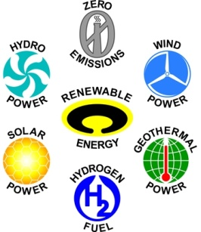***ONE DAY SEMINAR***

***On***

**New and Renewable Energy Forever**

***22nd February, 2012***

***Organized by***

**RENEWABLE ENERGY CLUB**

**R.V.R. & J.C. COLLEGE OF ENGINEERING**

**REGISTRATION FORM**

1. Name of the Institute :
2. Address:
3. Name of the students:

|  |  |
| --- | --- |
| *Sl. No.* | *Name* |
| 1. |  |
| 2. |  |
| 3. |  |
| 4. |  |

Station:

Date: PRINCIPAL / DIRECTOR

Seal

------------------------------------------------------------------------------------------------

Interested participants should send Registration form so as to reach us by on or before **14th February, 2012**.