NATIONAL SERVICE SCHEME
NSS VOLUNTARY SERVICES
SOCIAL OUTREACH PROGRAMMES
2013-2016
AT
DHARMAVARAM
(A REMOTE ADOPTED VILLAGE IN DURGI MD, GUNTUR DIST)
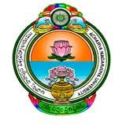
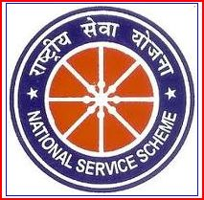

NSS UNIT

R.V.R. & J.C. COLLEGE OF ENGINEERING
(AUTONOMOUS)
CHANDRAMOULIPURAM:: CHOWDAVARAM
GUNTUR-522 019:: ANDHRA PRADESH
Phones :( 0863) 2288201 to 204; 2232505;
Cell: 9491073317, 318
Fax:0863-2350343, 2288274
E-mail: rvrjcce@hotmail.com
Website: rvrjcce.ac.in

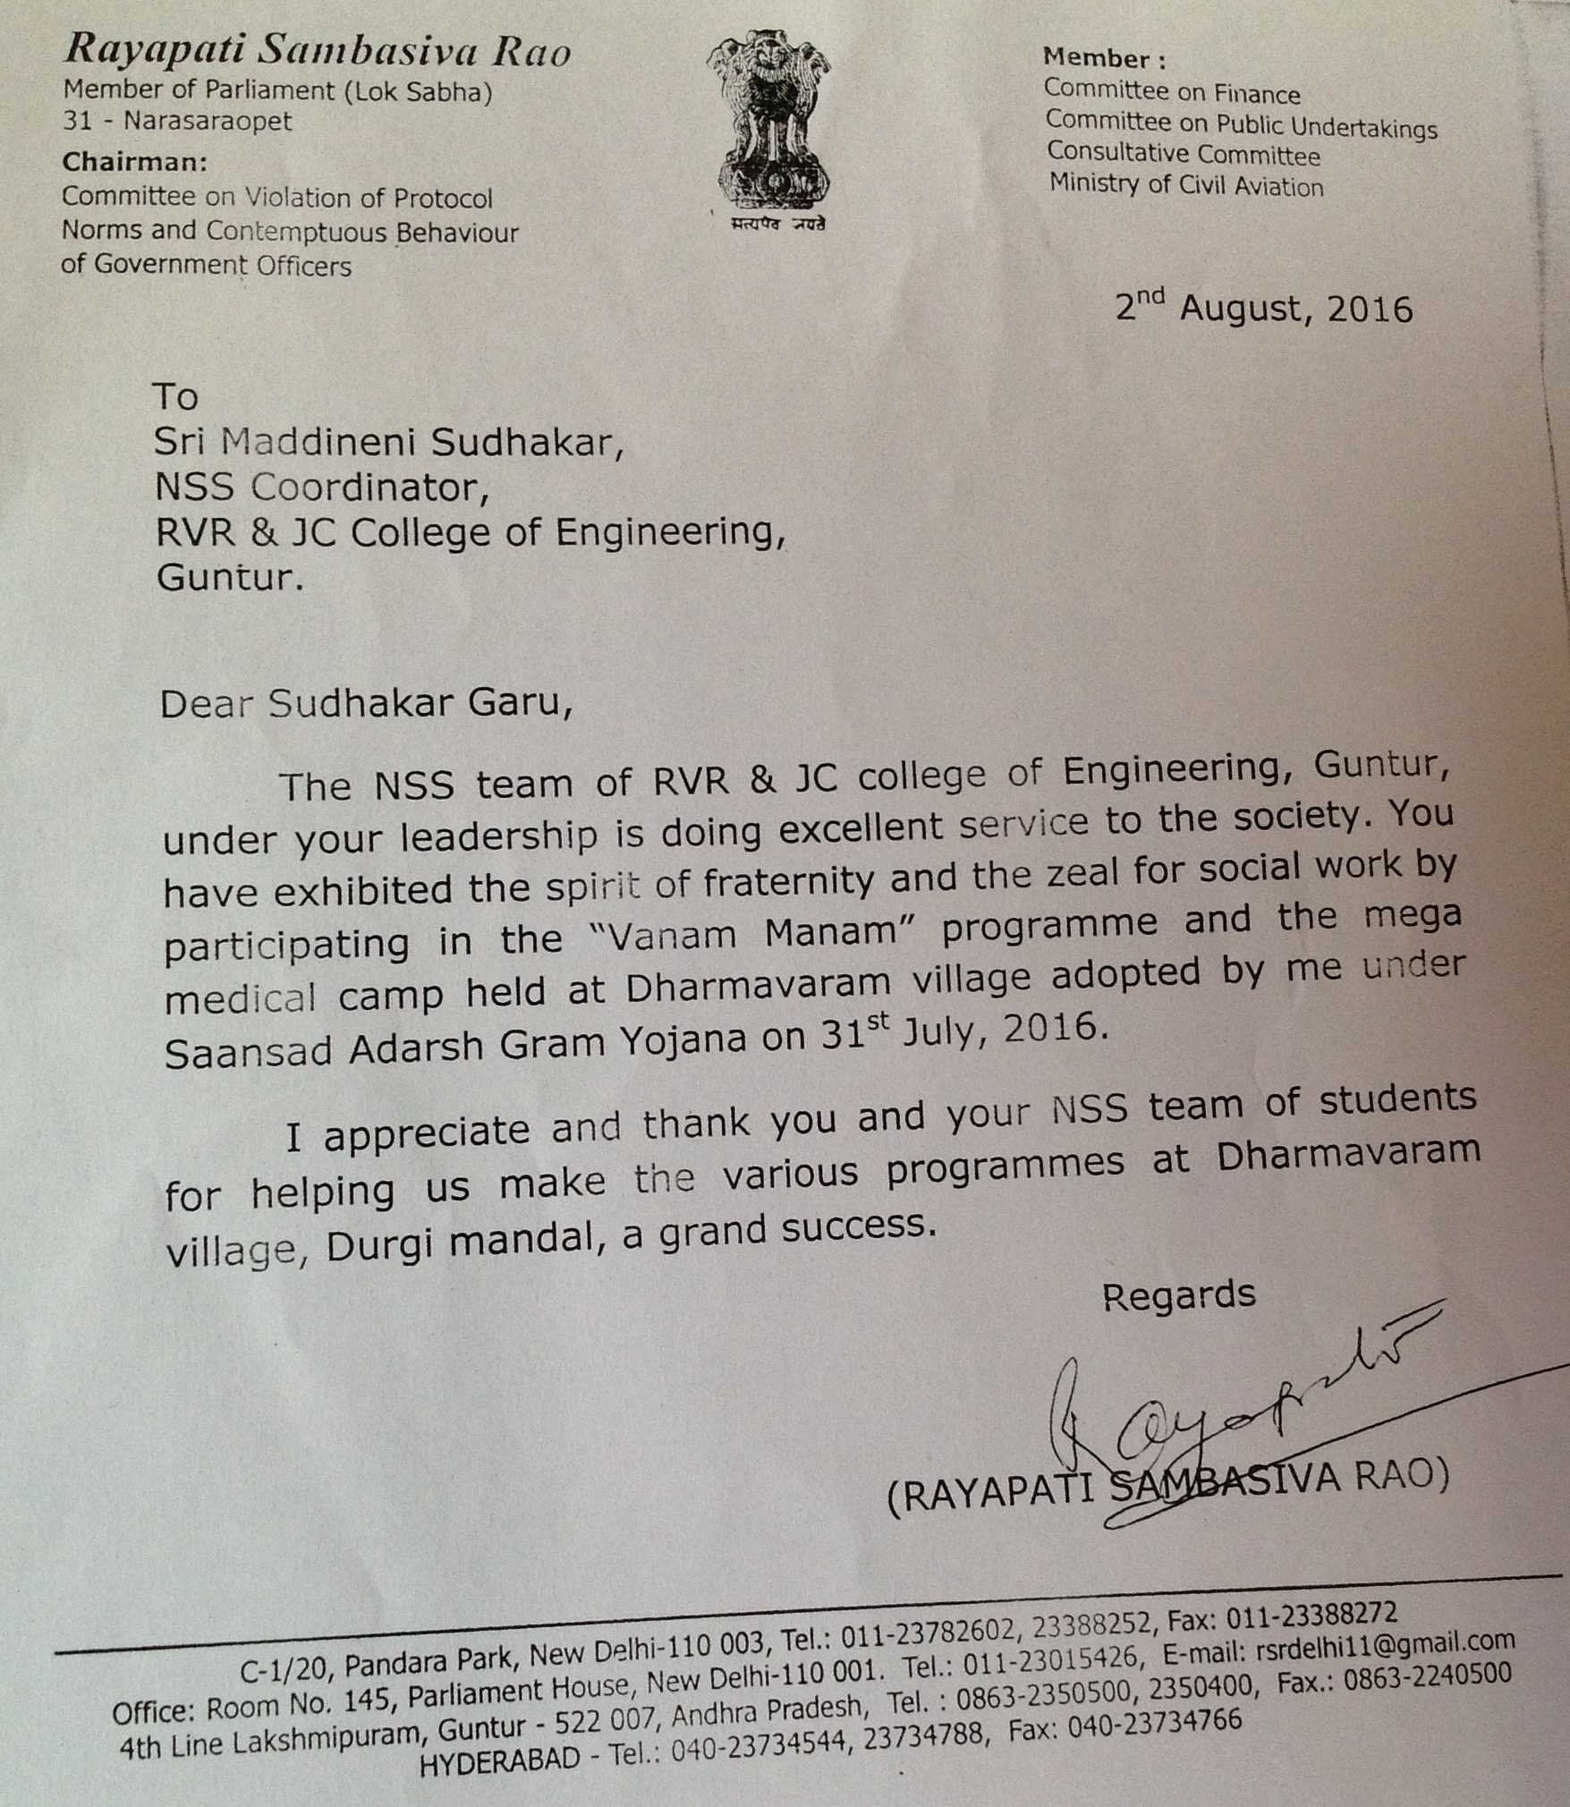

SWACHH BHARATH PROGRAMME
INAUGURATION OF SWACHH BHARATH PROGRAMME BY
SRI RAYAPATI SAMBA SIVA RAO, MP (LOK SABHA, NARASARAOPET)
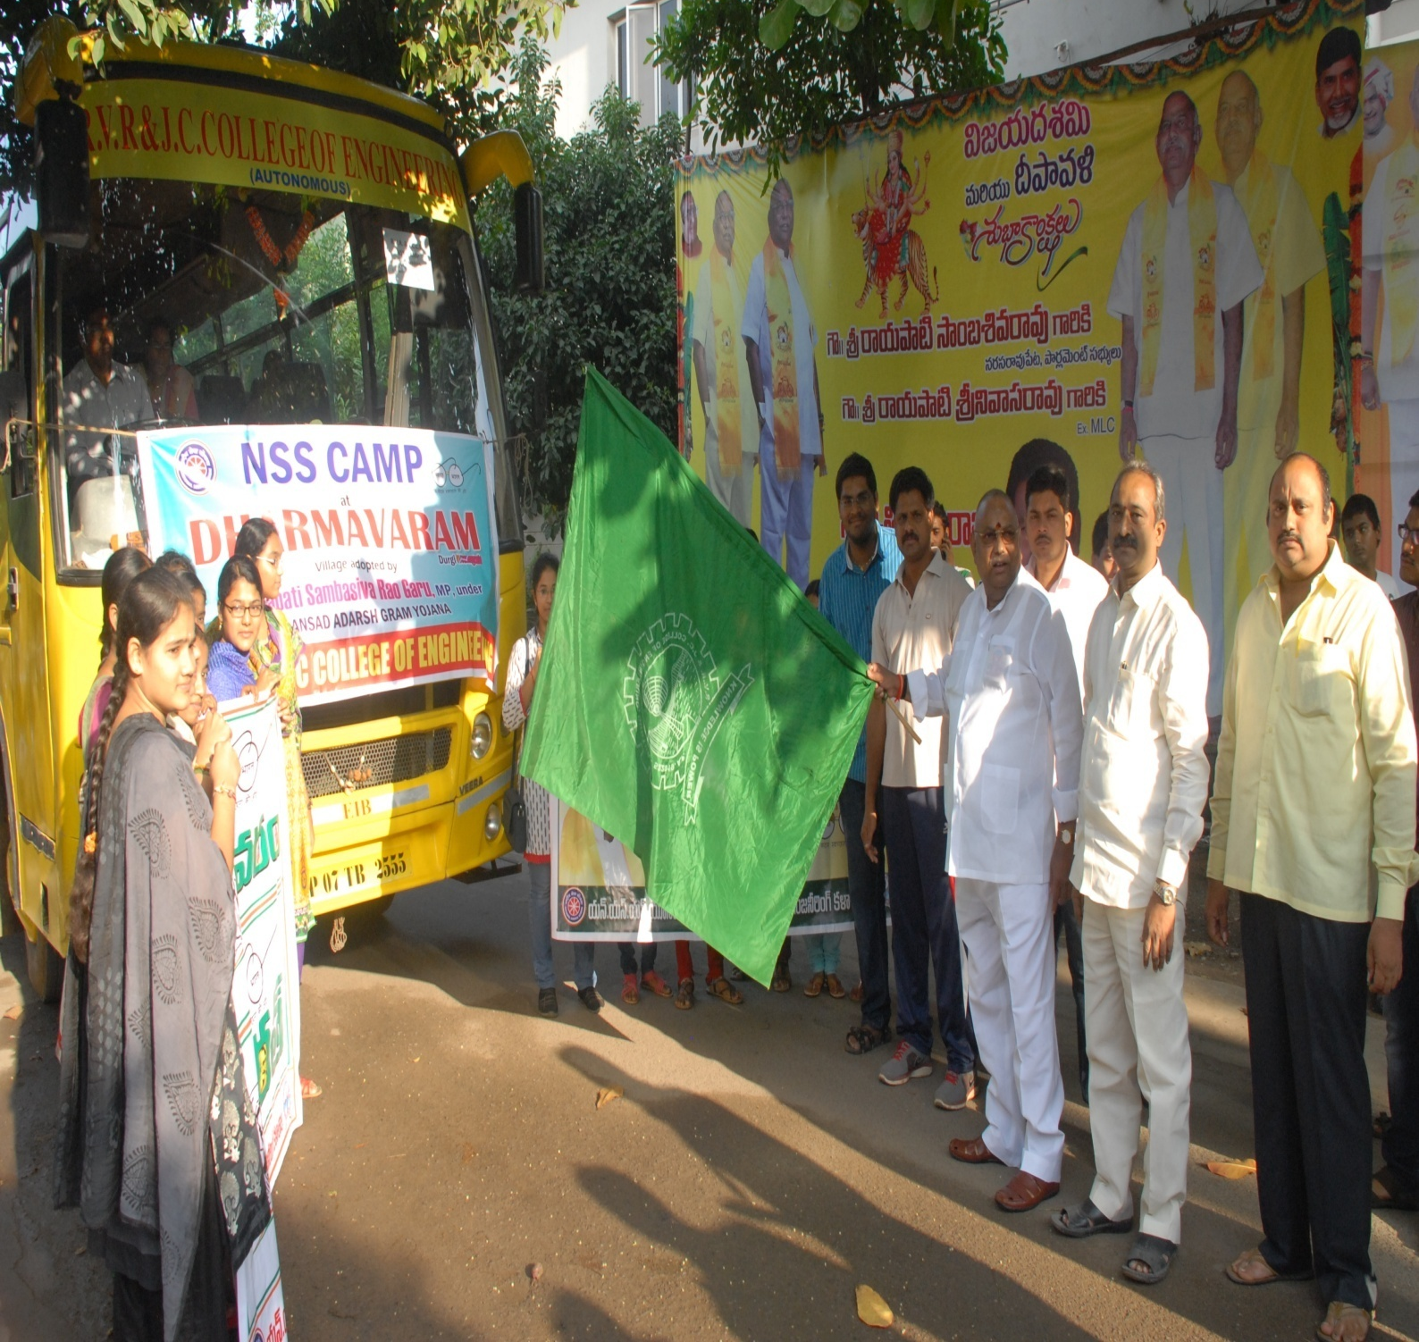

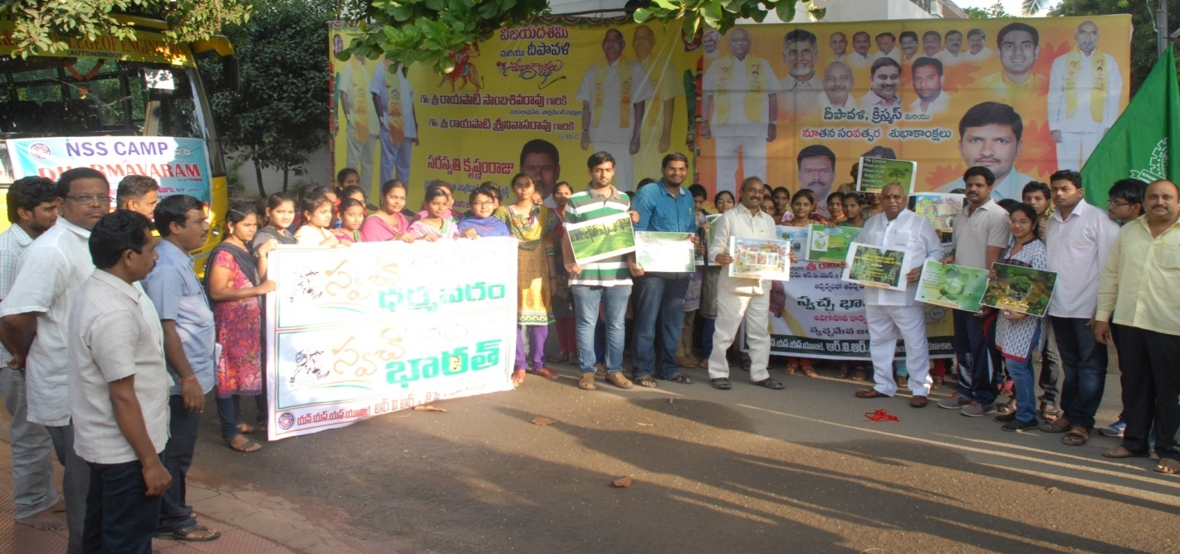
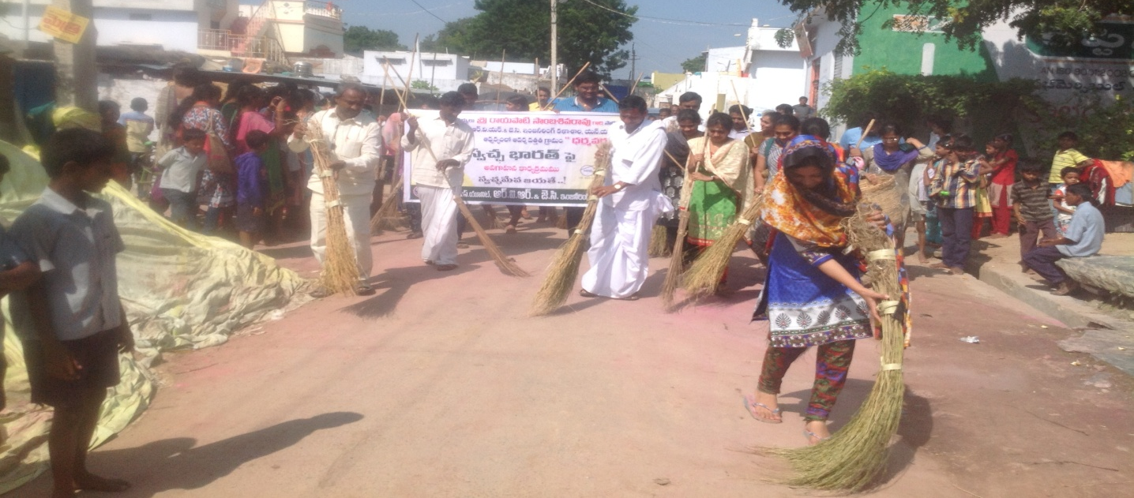
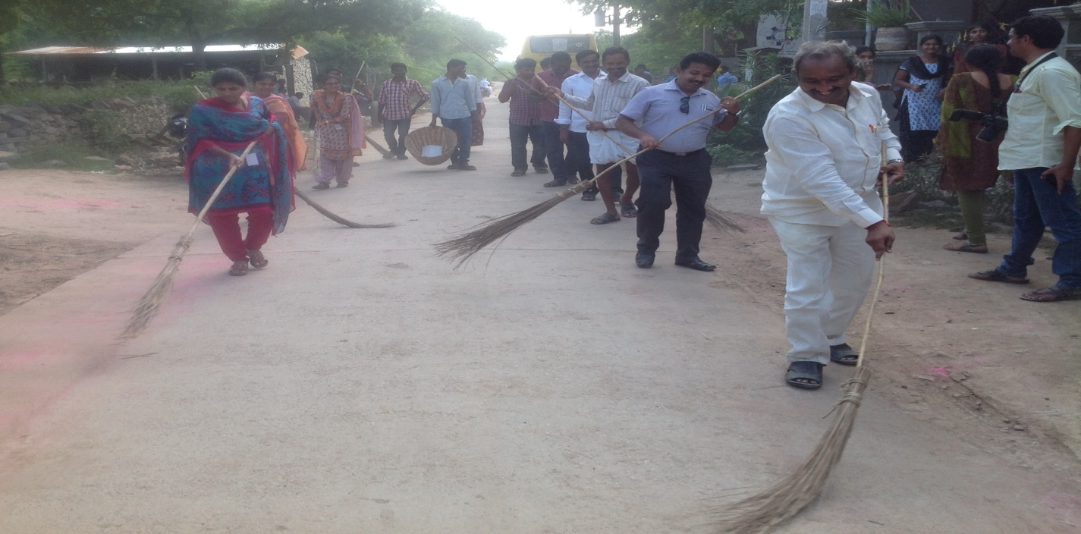
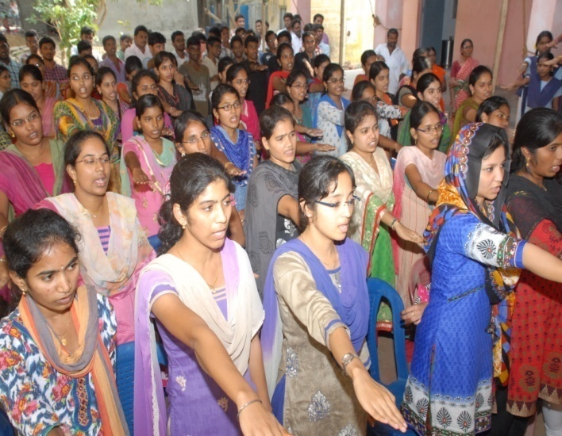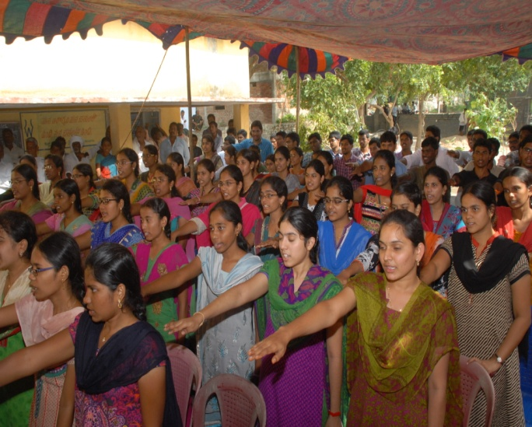
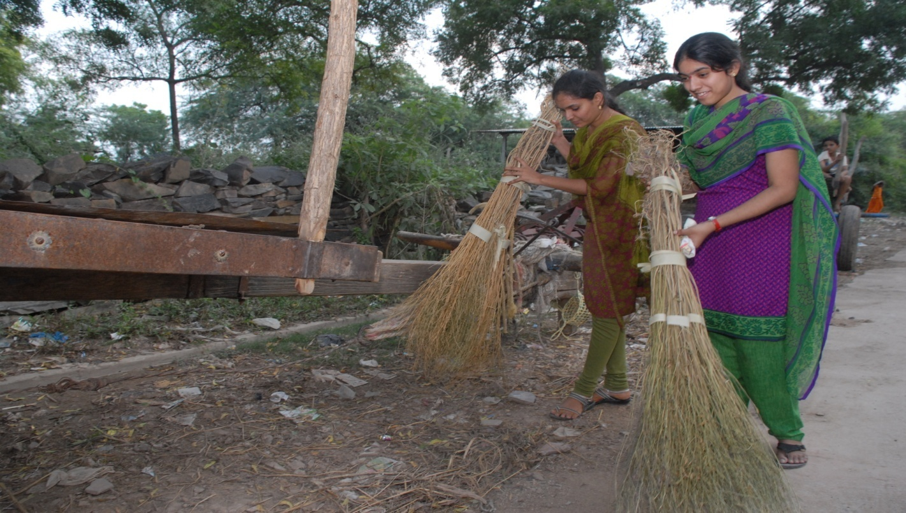
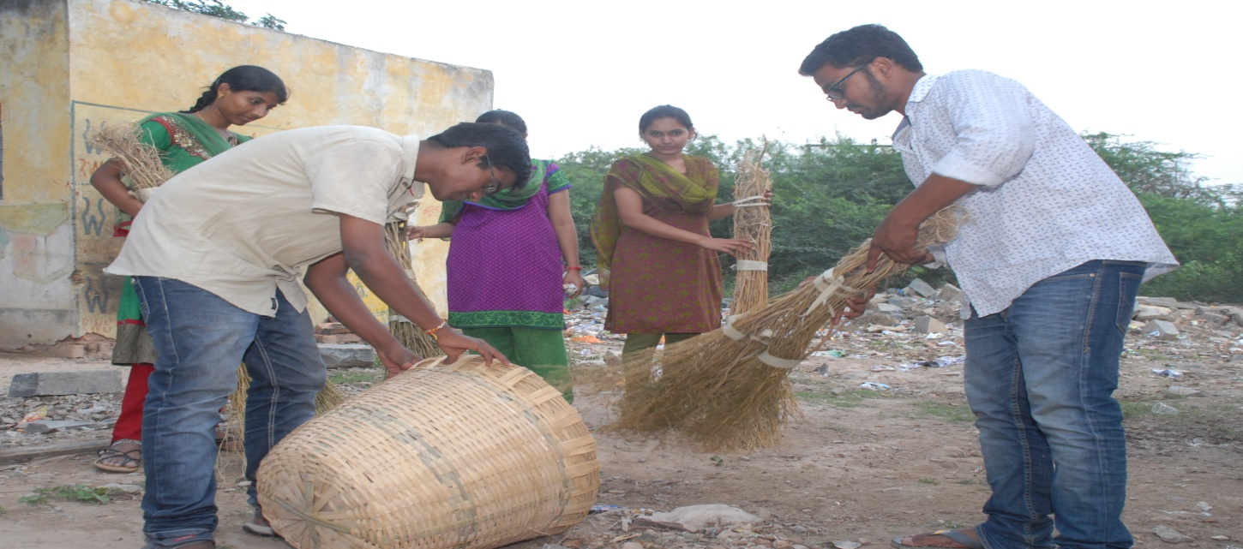

MEGA PLANTATION PROGRAMME
INAUGURATION OF MEGA PLANTATION PROGRAMME BY
SRI RAYAPATI SAMBA SIVA RAO, MP (LOK SABHA, NARASARAOPET)

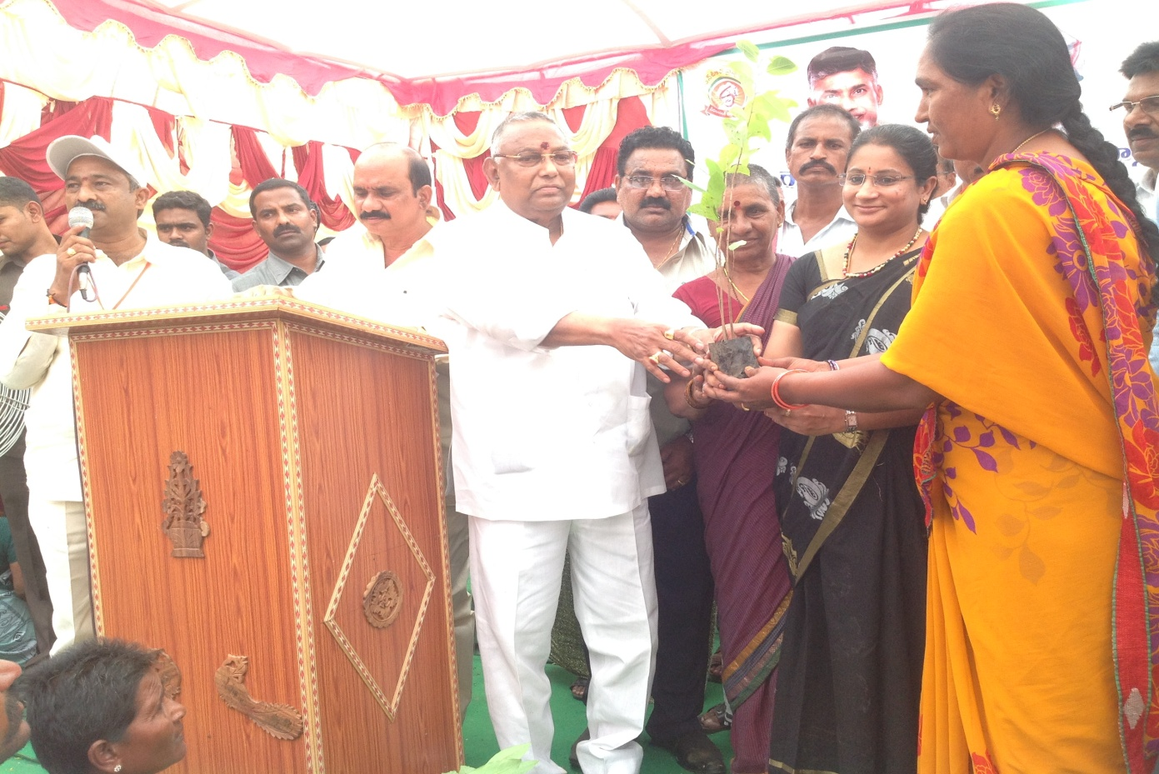
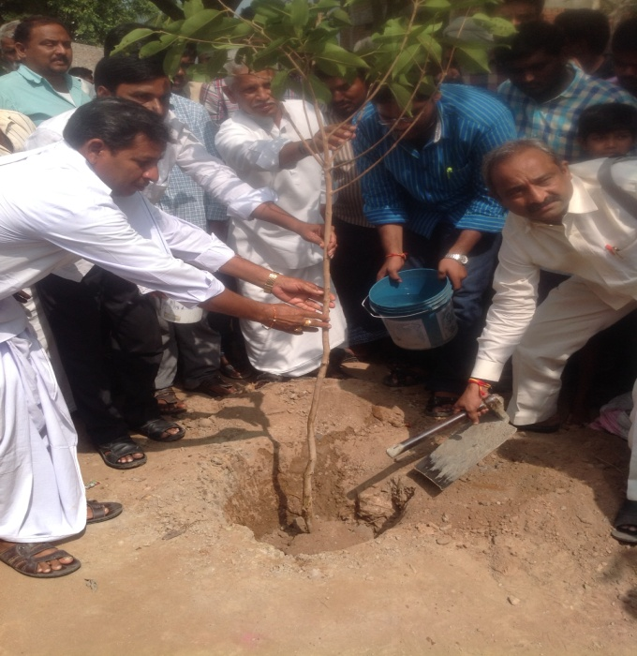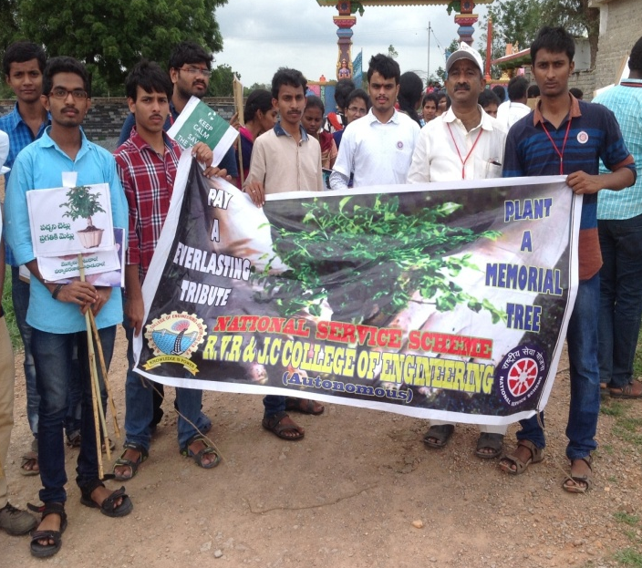
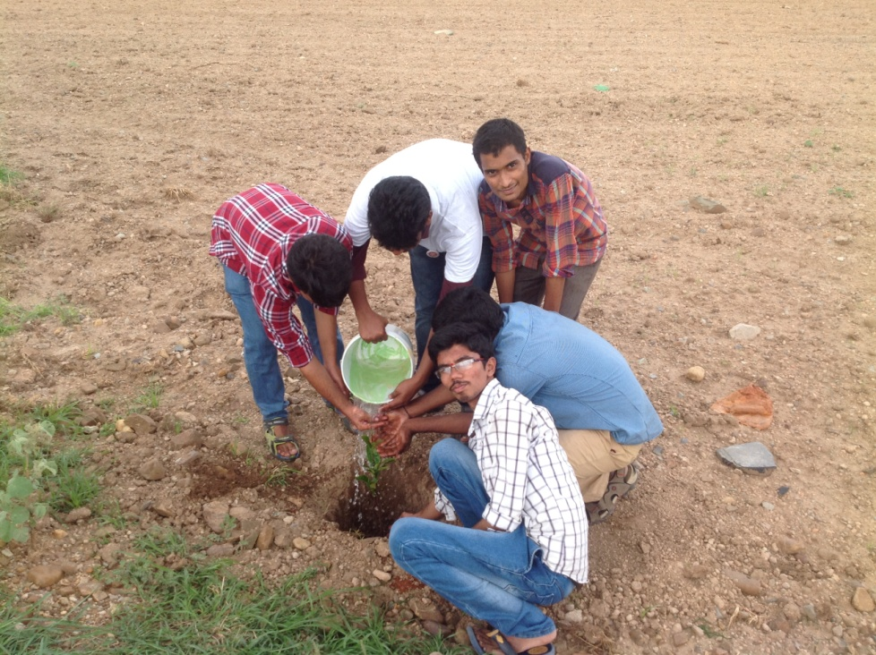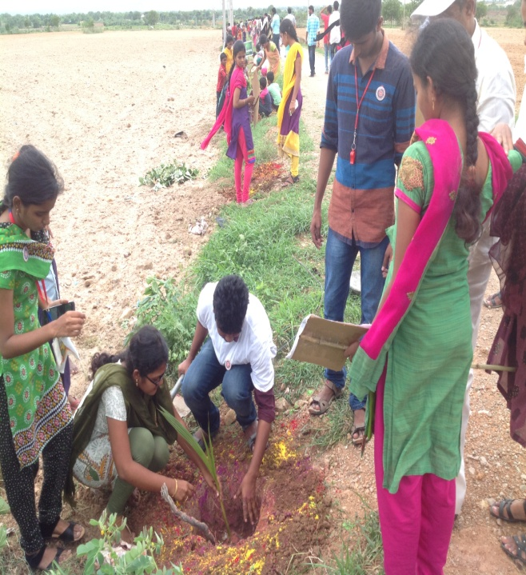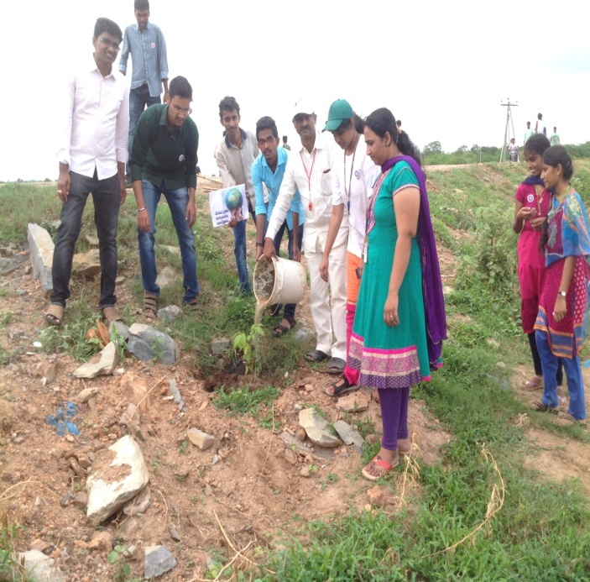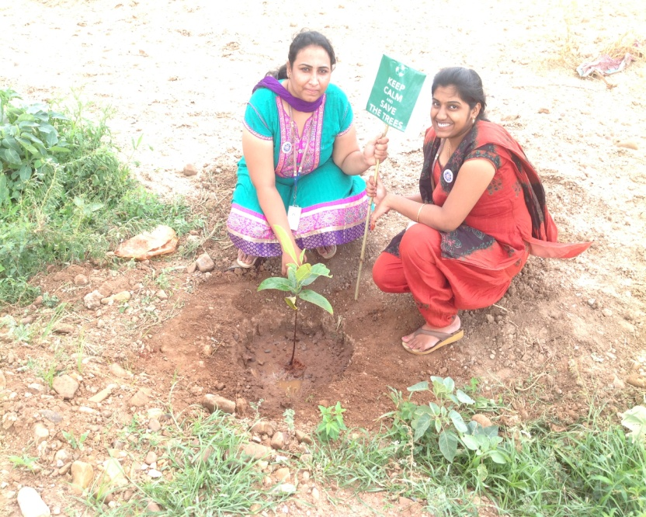
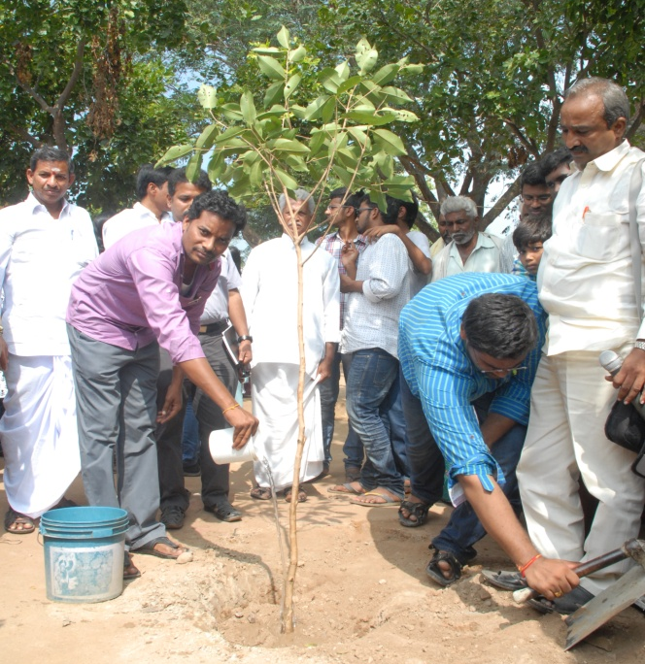
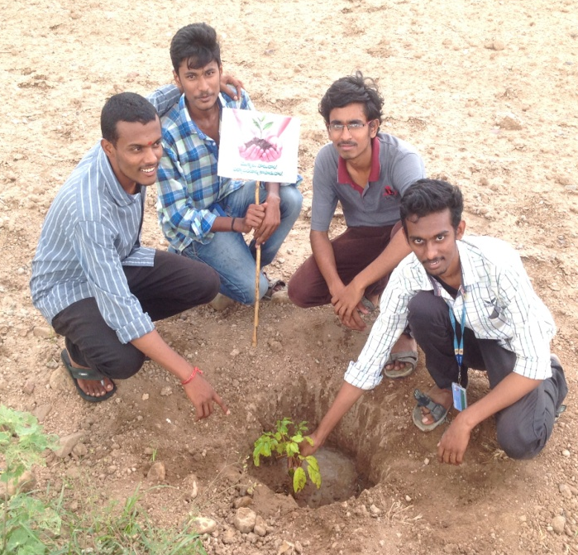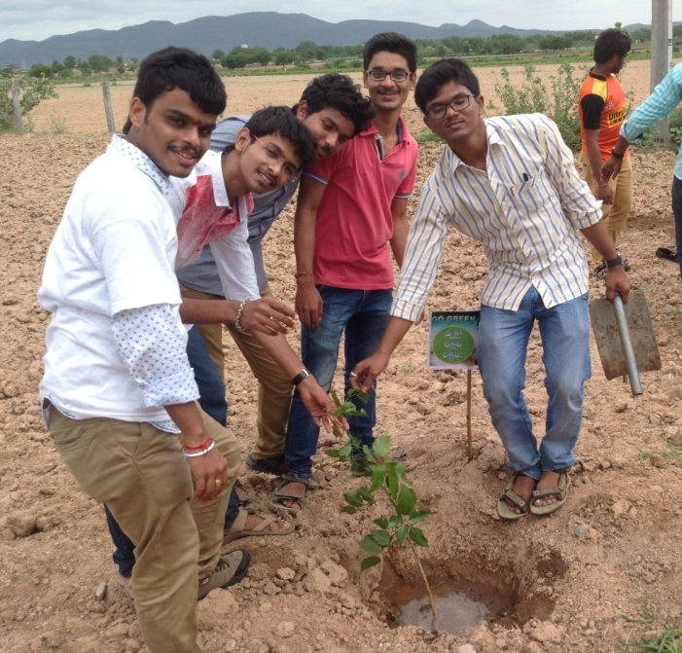
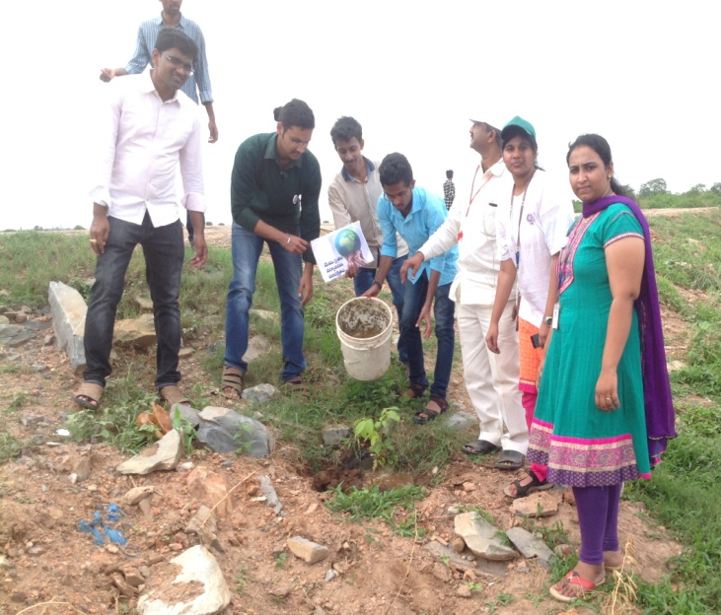
EDUCATIONAL AWARENESS PROGRAMME
INAUGURATION OF EDUCATIONAL AWARENESS PROGRAMME BY
SRI RAYAPATI SAMBA SIVA RAO, MP (LOK SABHA, NARASARAOPET)
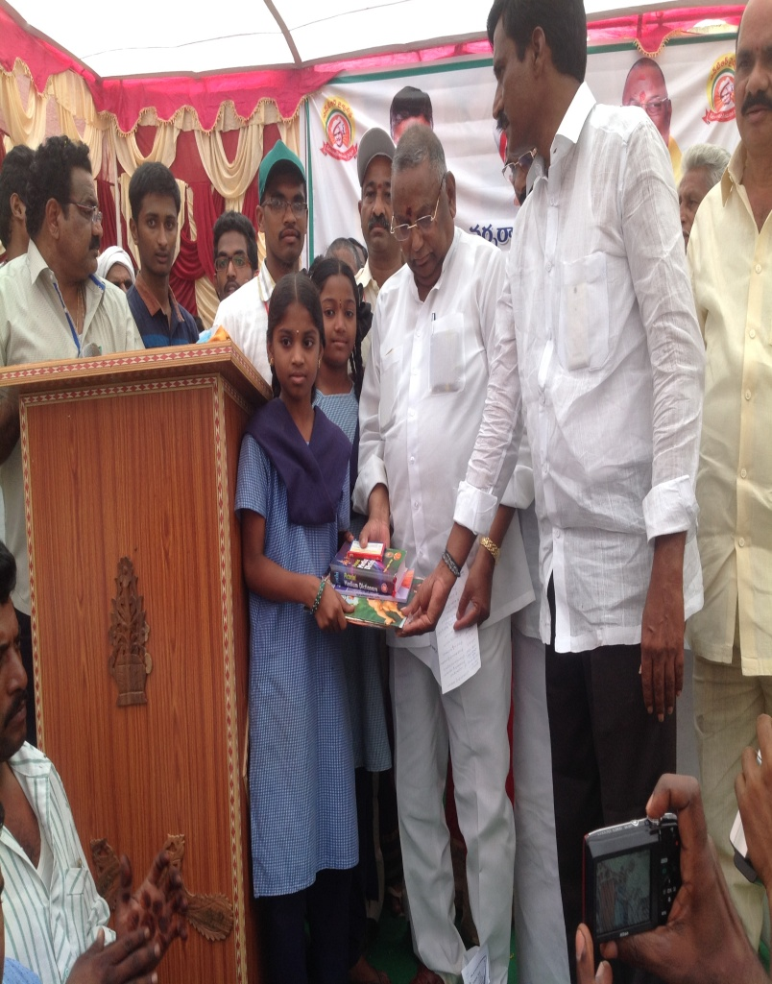
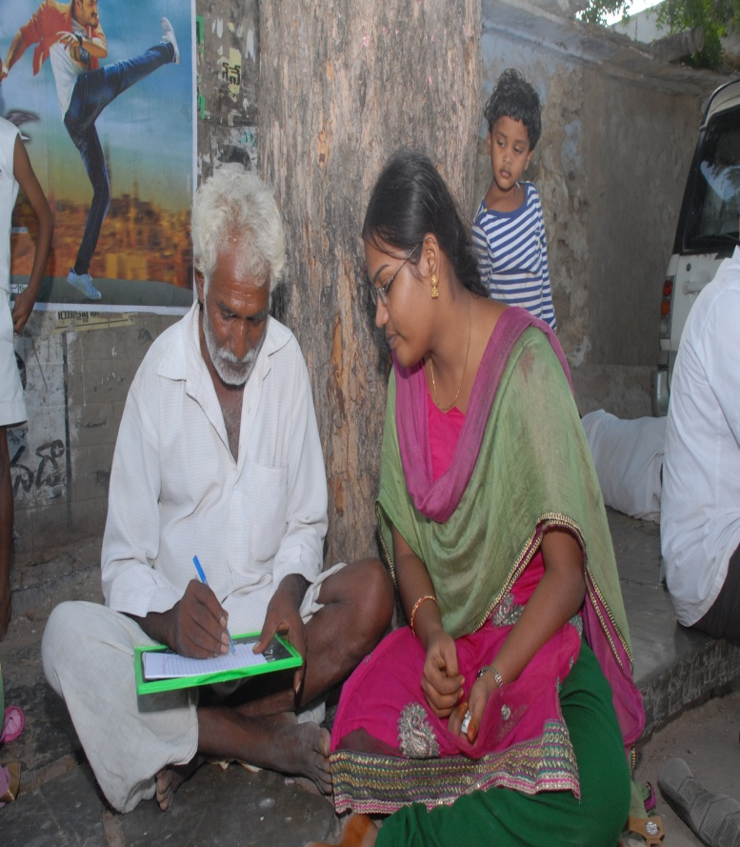
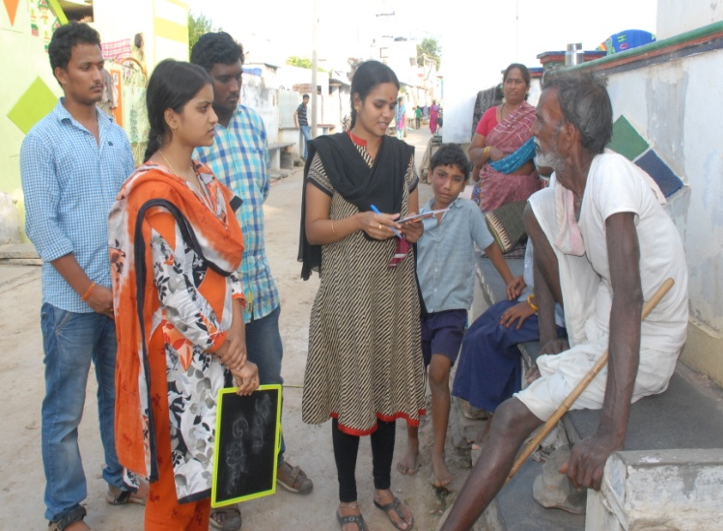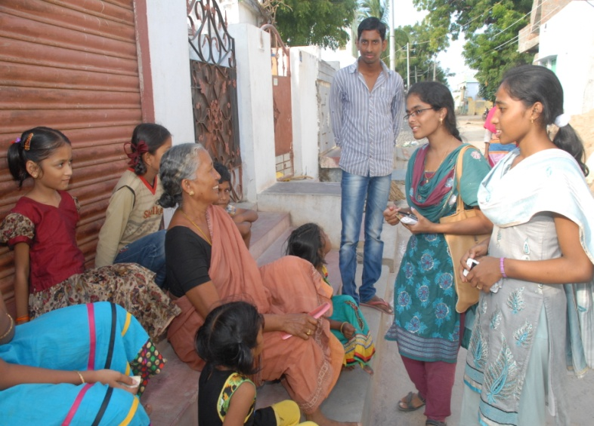
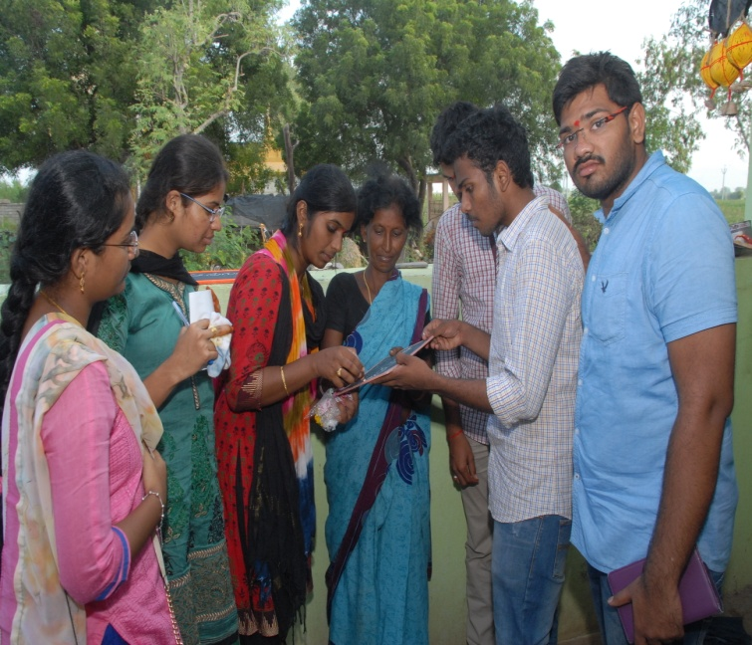
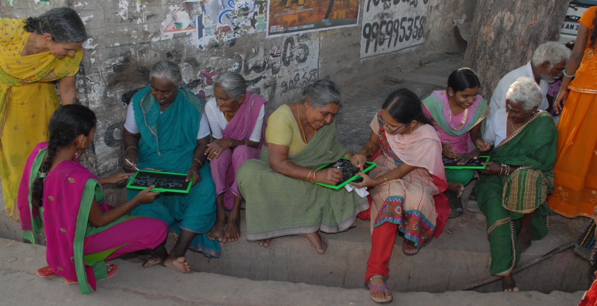
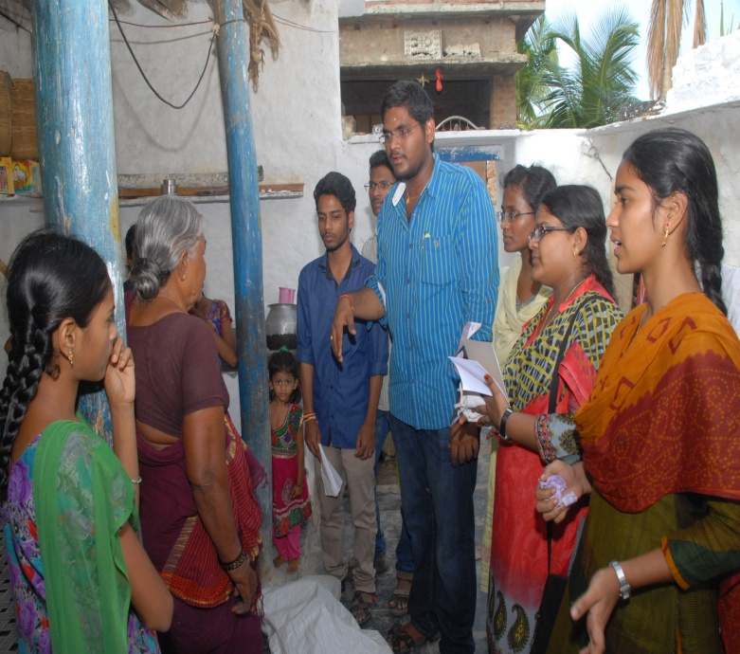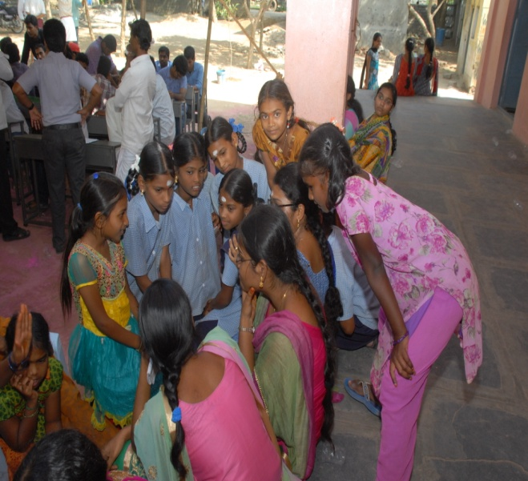
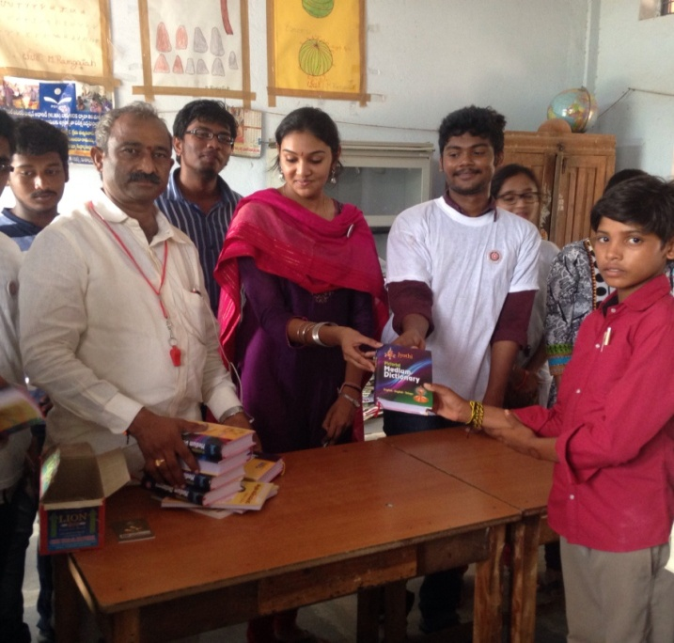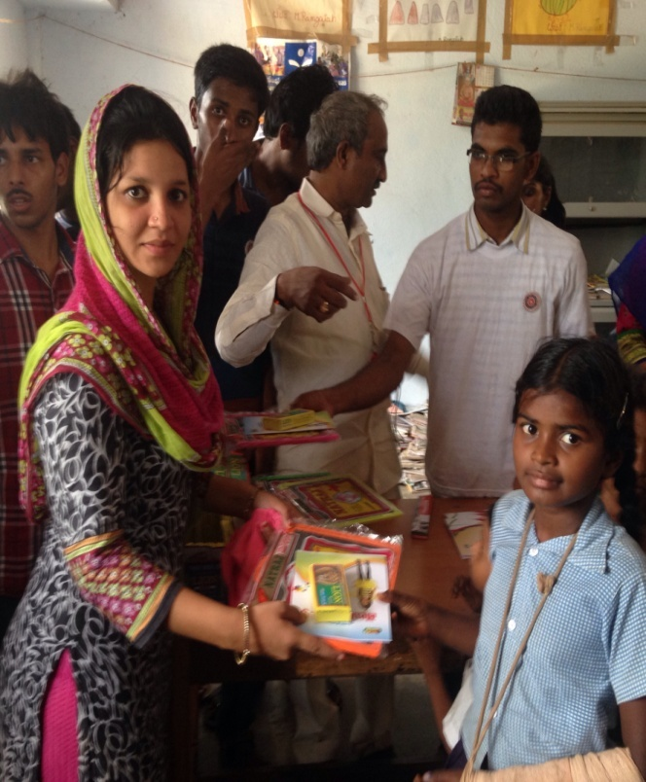
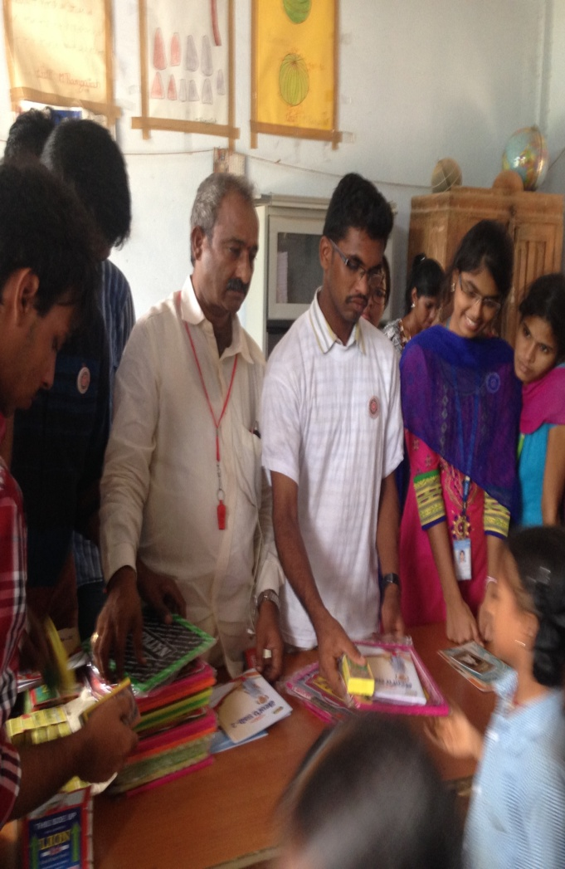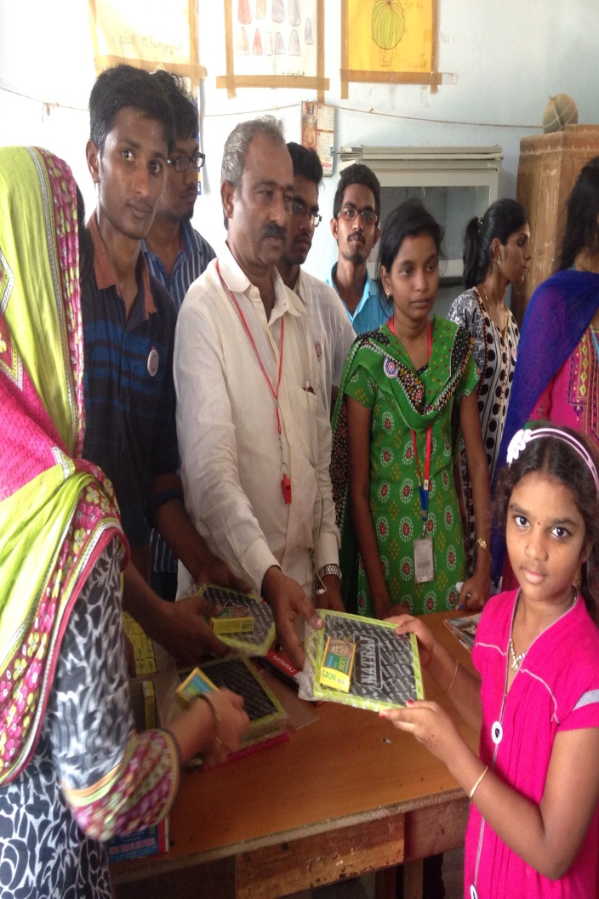

MEDICAL, DENTAL AND EYE CAMP
INAUGURATION OF HEALTH CAMPS BY
SRI RAYAPATI SAMBA SIVA RAO, MP (LOK SABHA, NARASARAOPET)
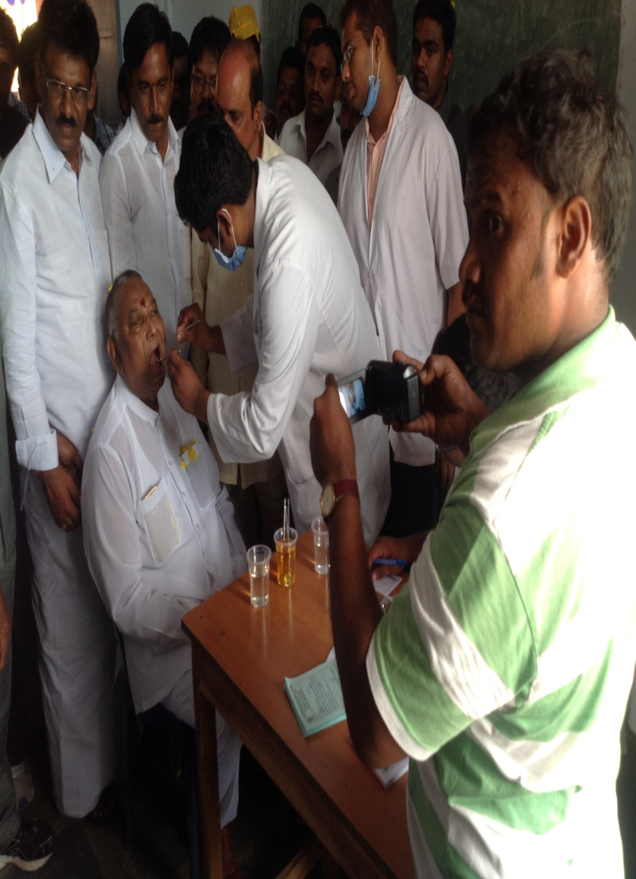

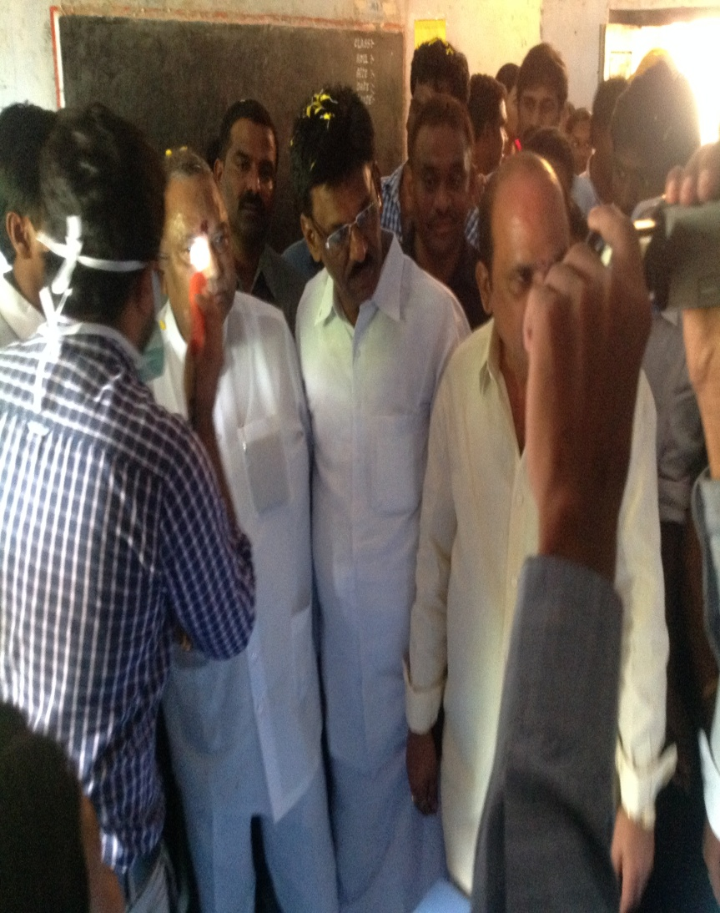
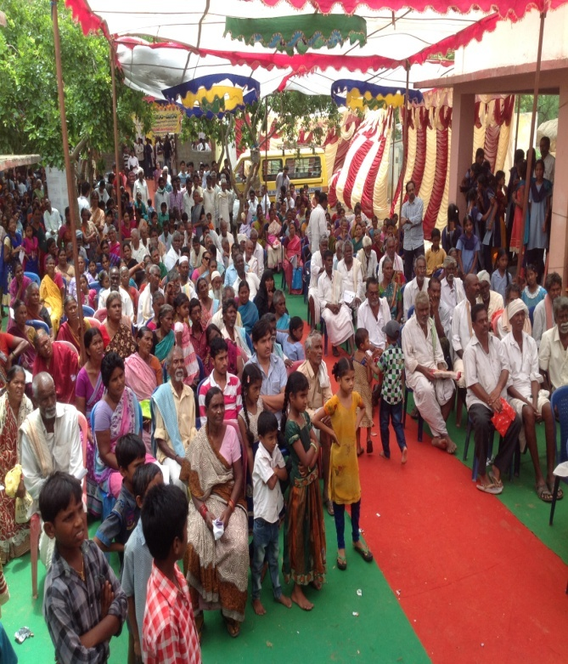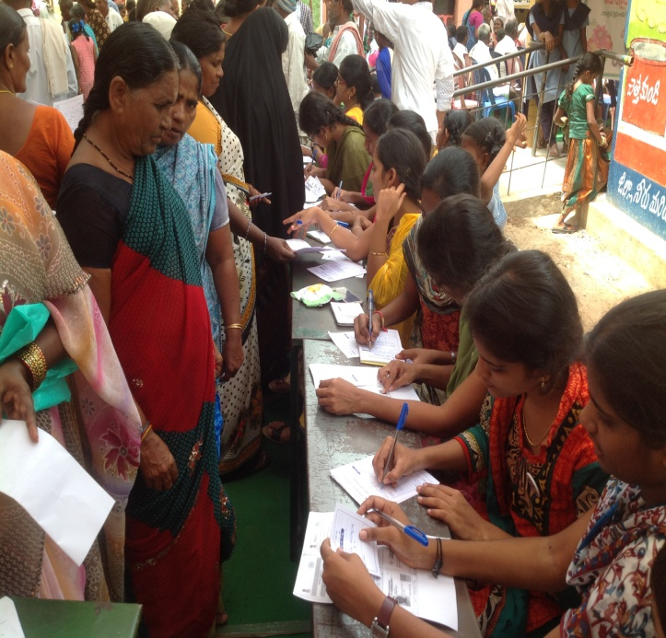
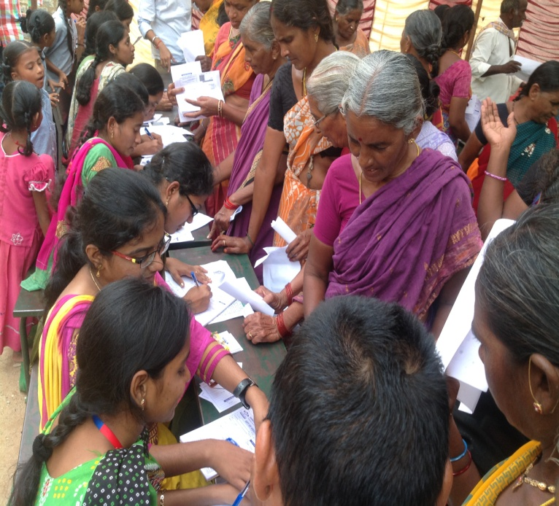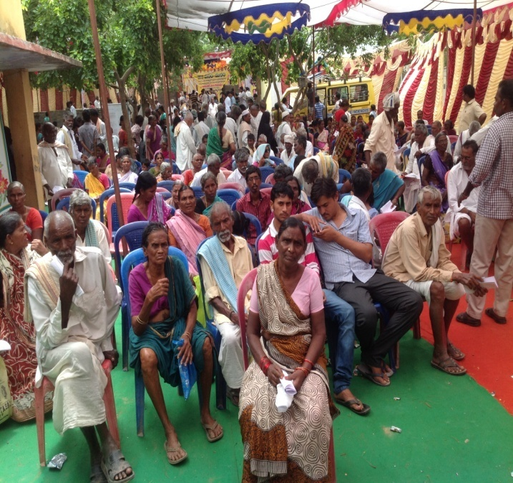
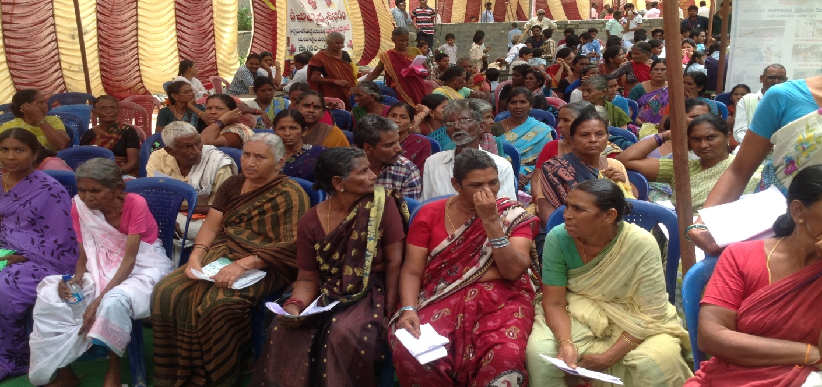
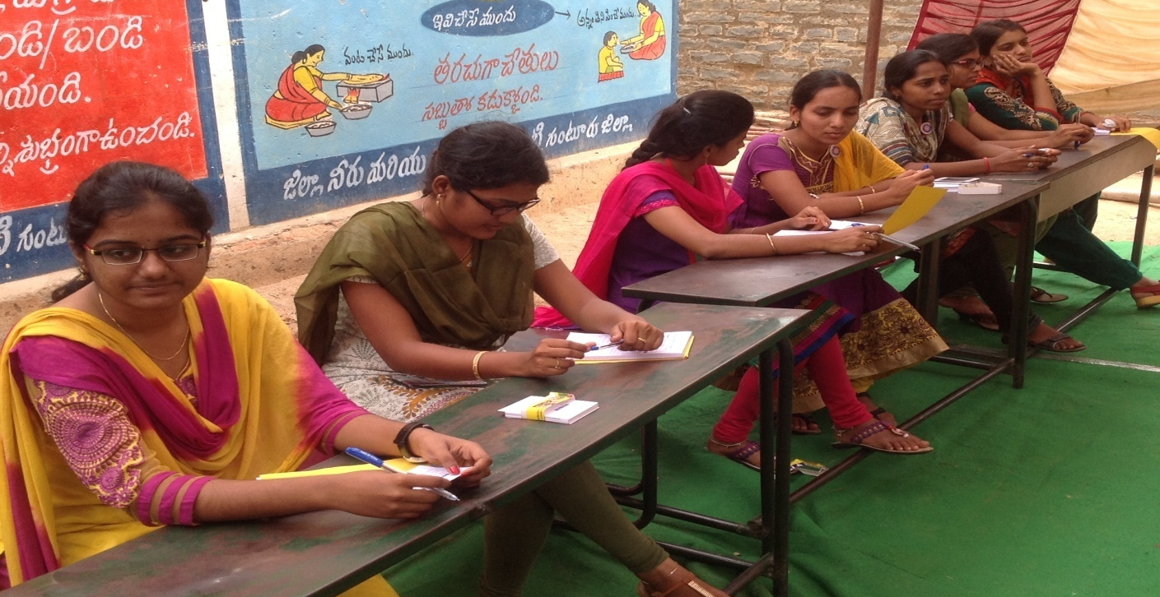
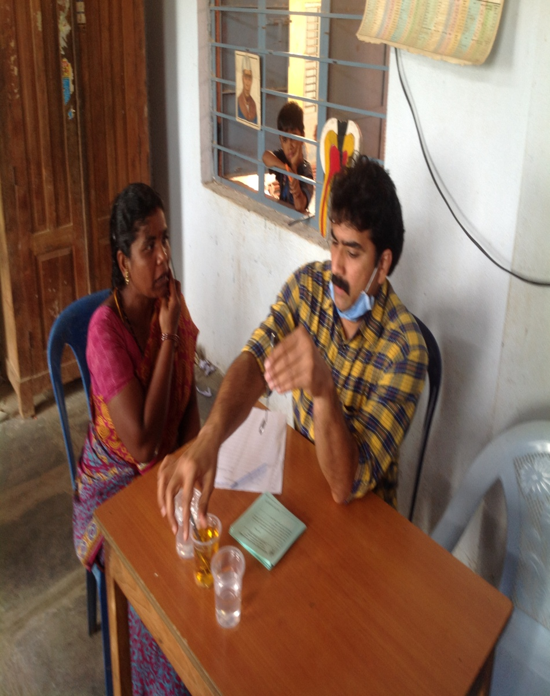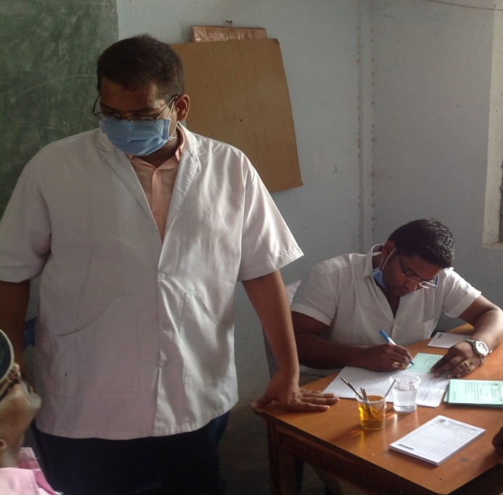
PERCULATION PITS
INAUGURATION OF PERCOLATION PITS BY
SRI RAYAPATI SAMBA SIVA RAO, MP (LOK SABHA, NARASARAOPET)
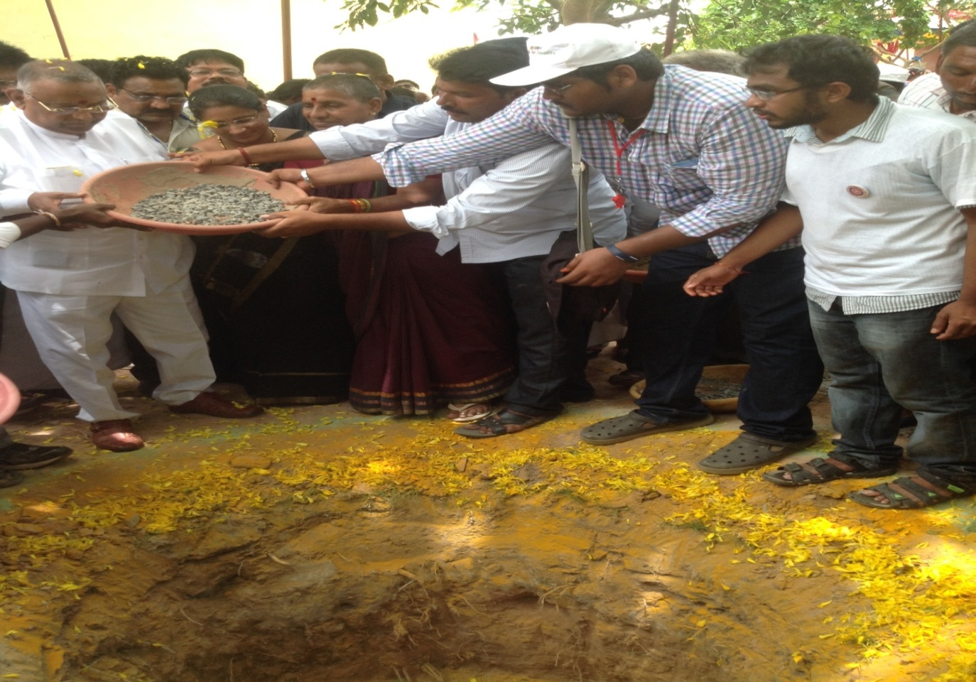
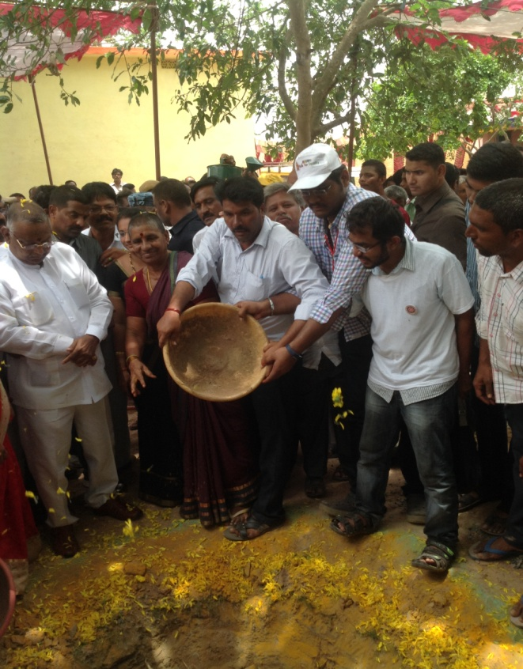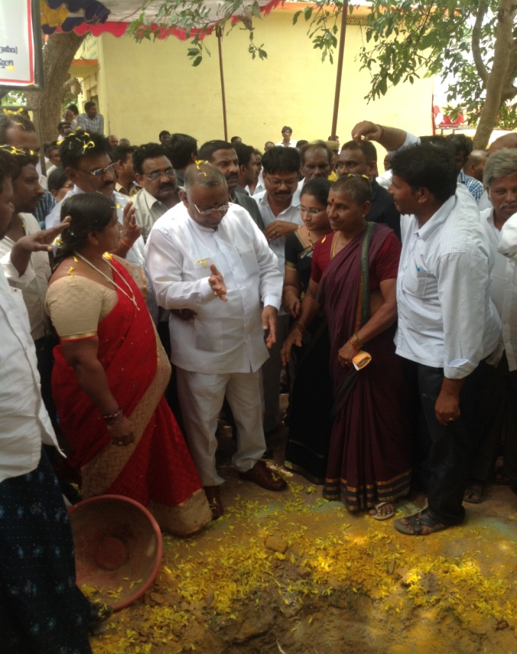
VILLAGE LEVEL AWARENESS PROGRAMMES
WITH CH.MADHU, VILLAGE PRESIDENT
SRI SAJI, PS TO MP
VILLAGE VICE PRESIDENT ALONG WITH NSS PO AND VOLUNTEERS

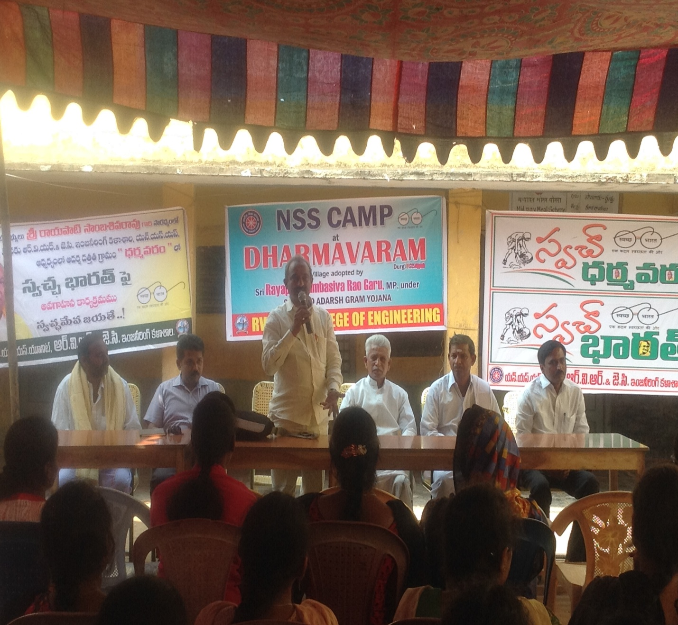
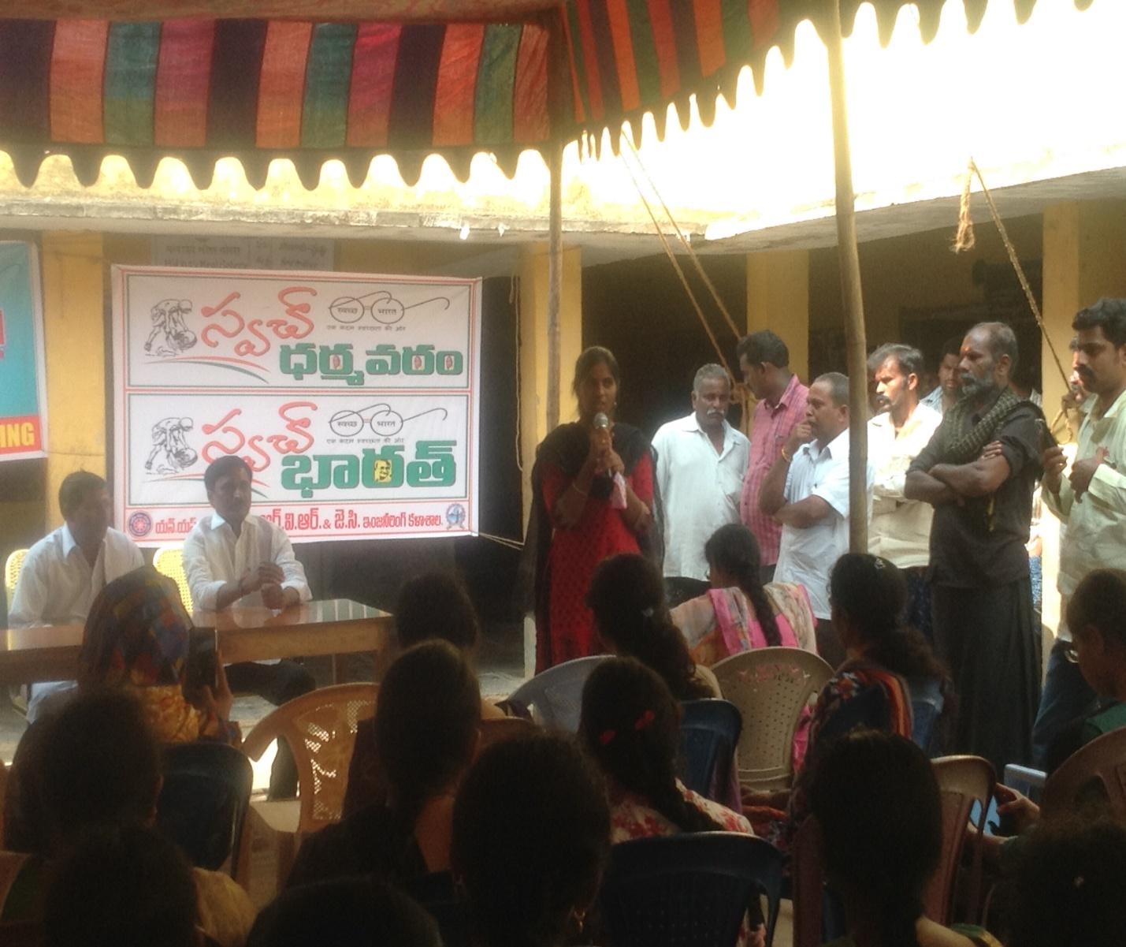
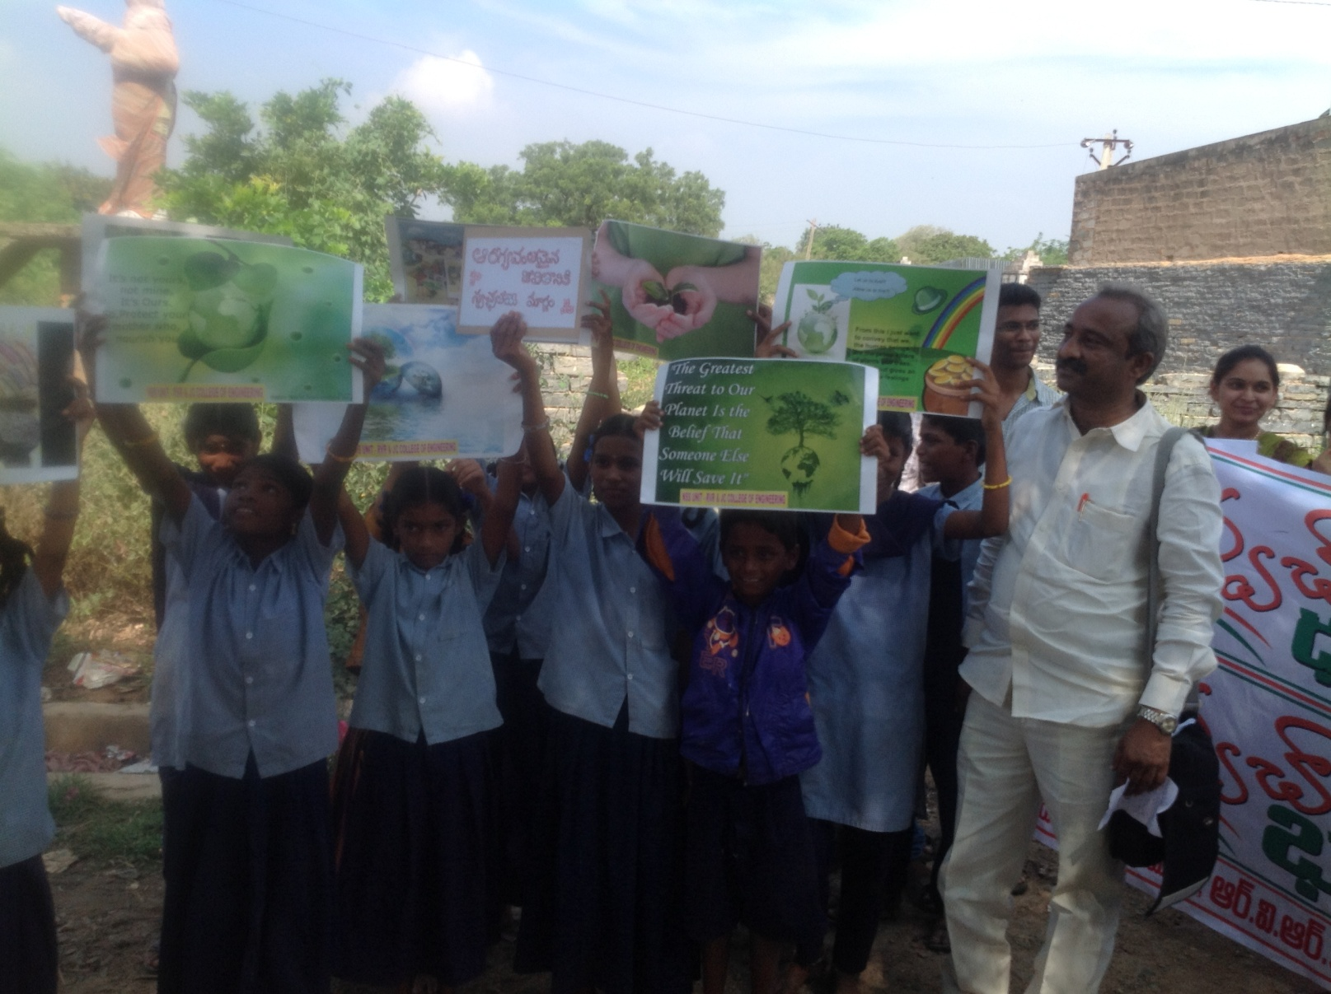
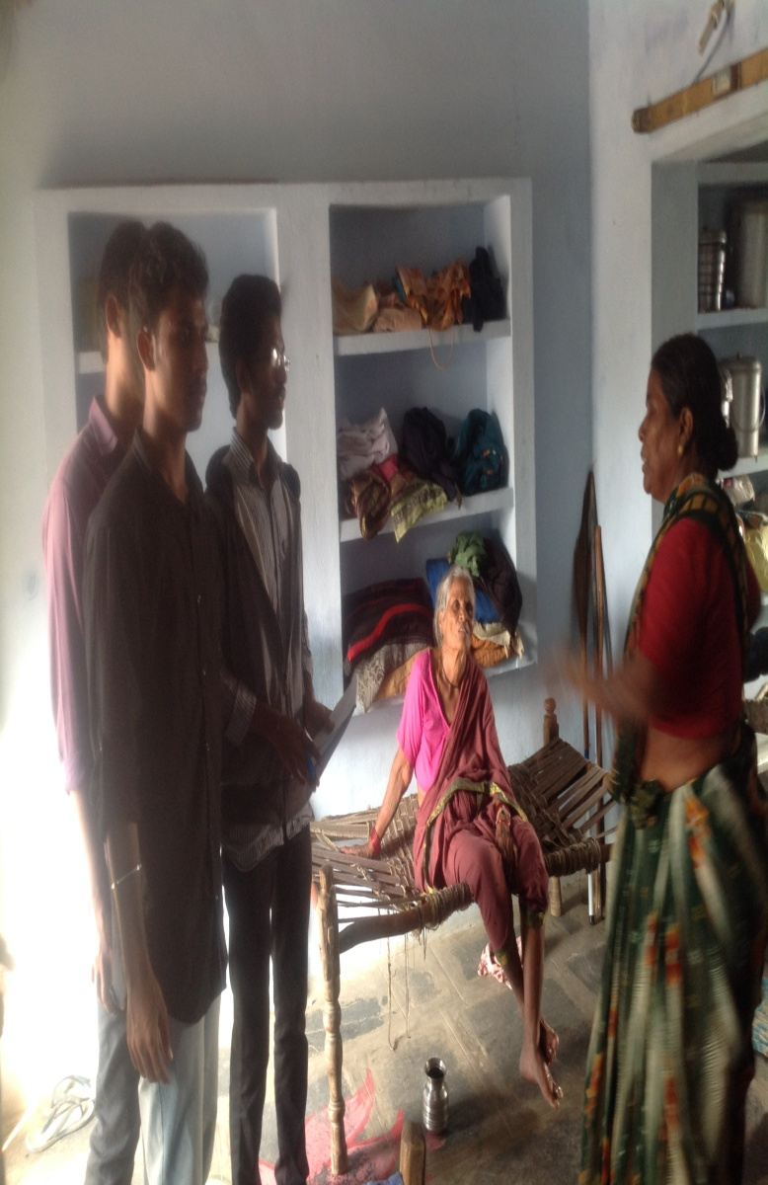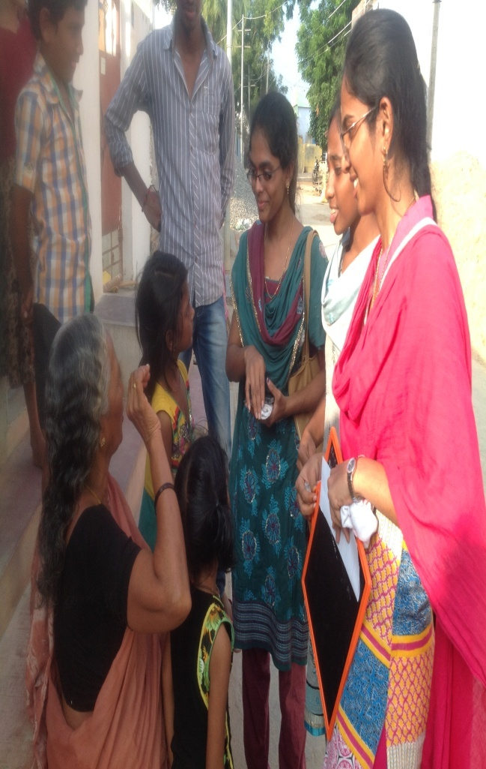
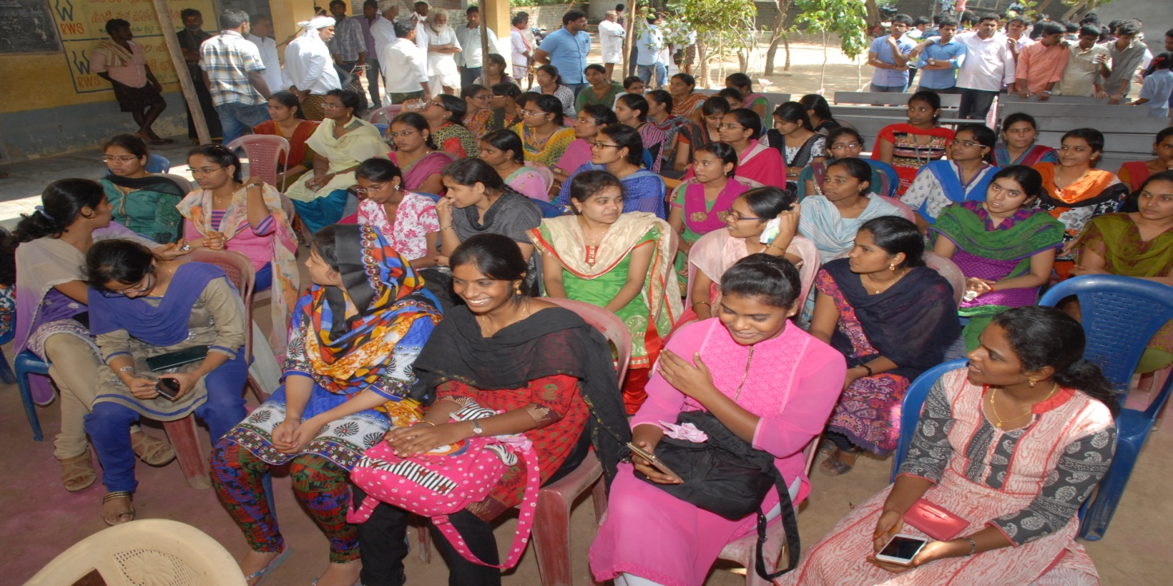
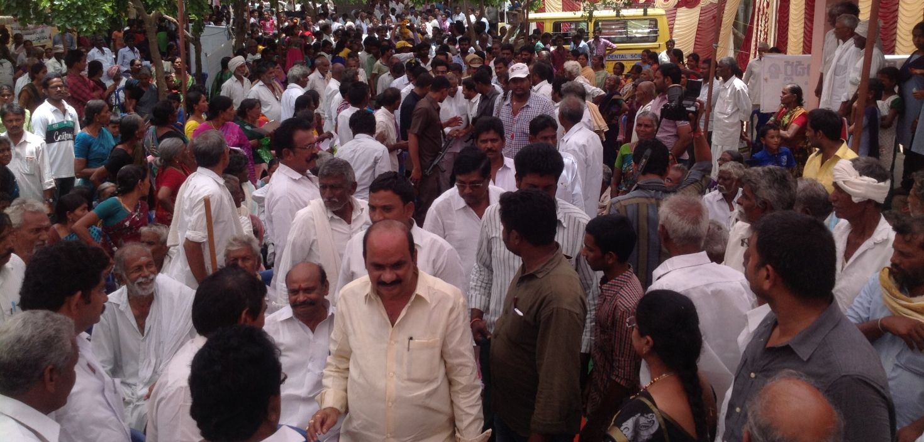

AWARENESS RALLIES ON PLANTATION, EDUCATION, HEALTH AND HYGIENE
WITH CH.MADHU, VILLAGE PRESIDENT
SRI SAJI, PS TO MP
VILLAGE VICE PRESIDENT ALONG WITH NSS PO AND VOLUNTEERS

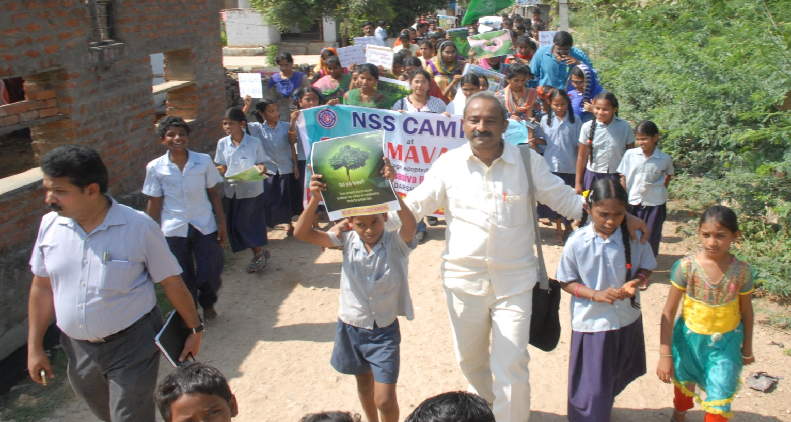
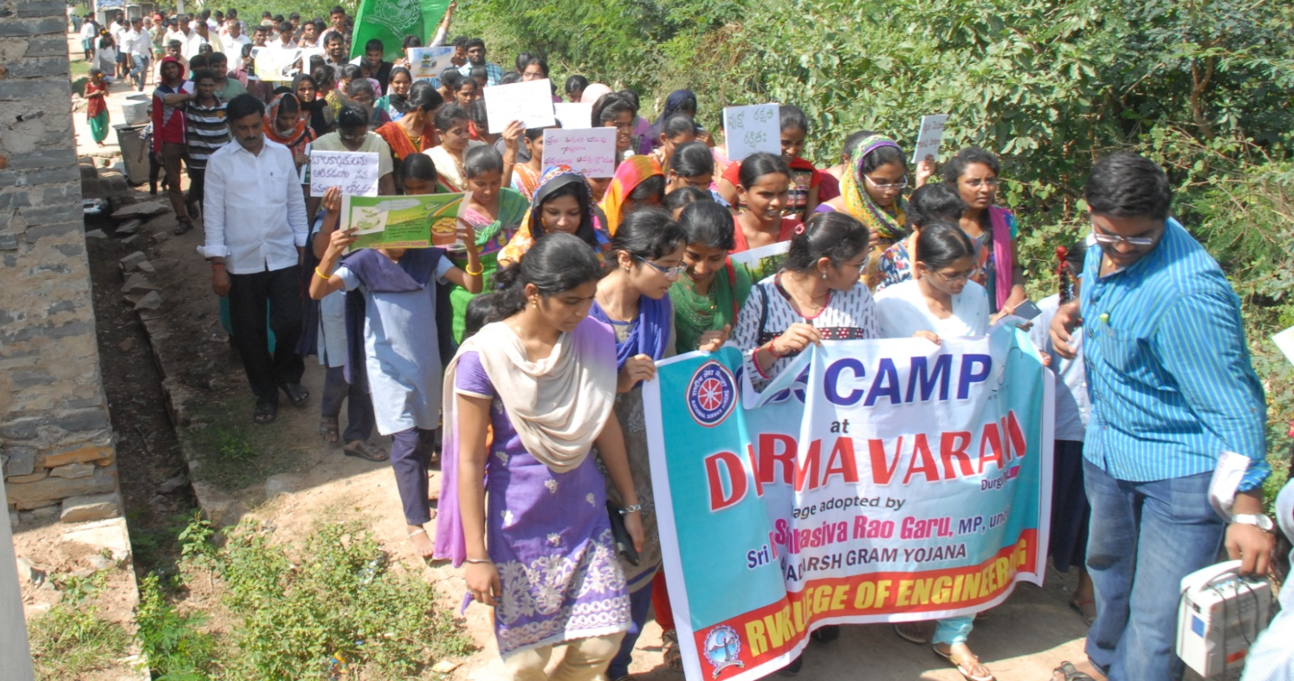

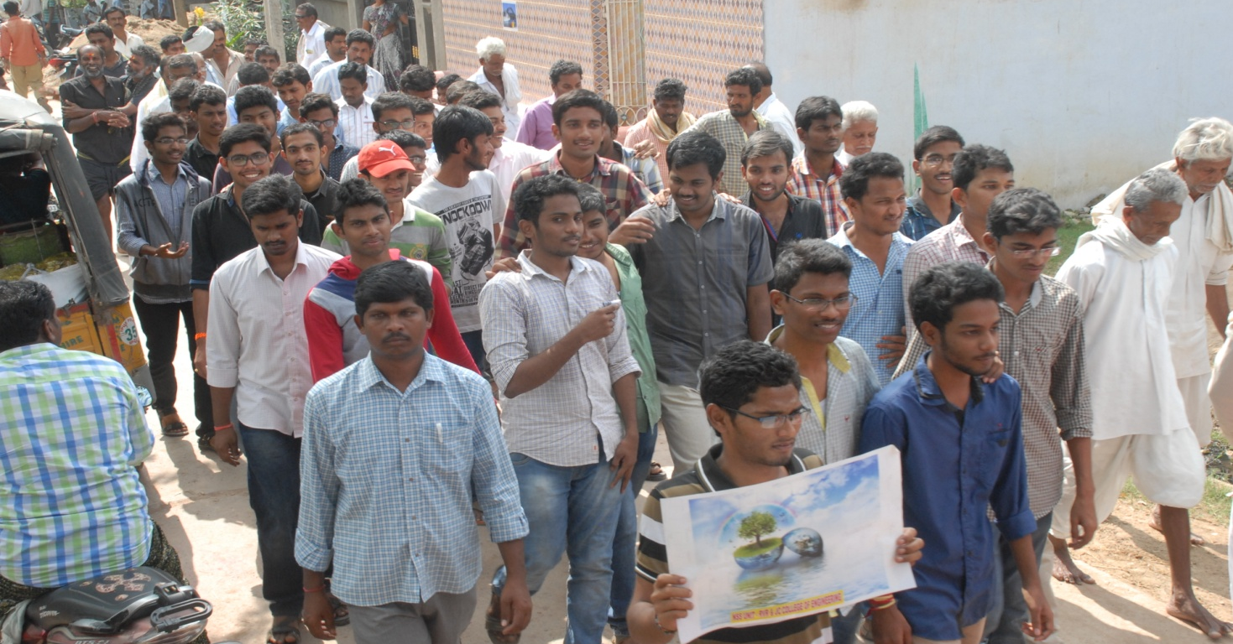
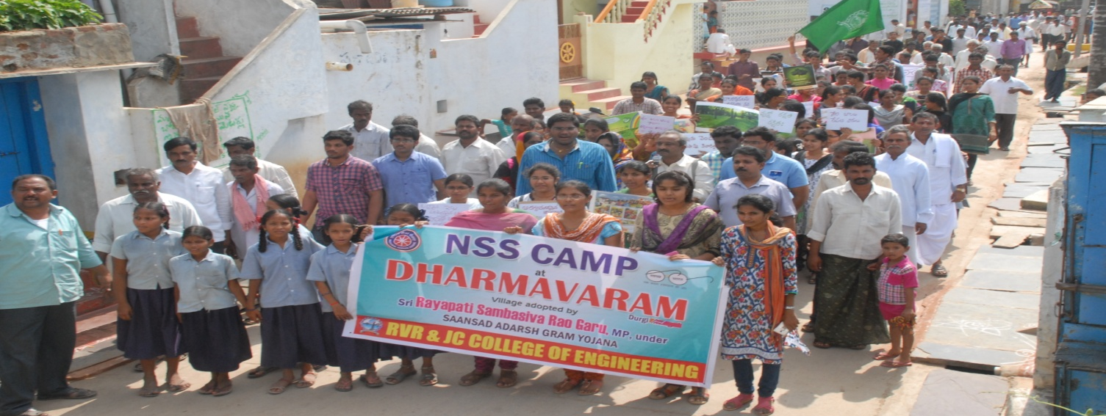
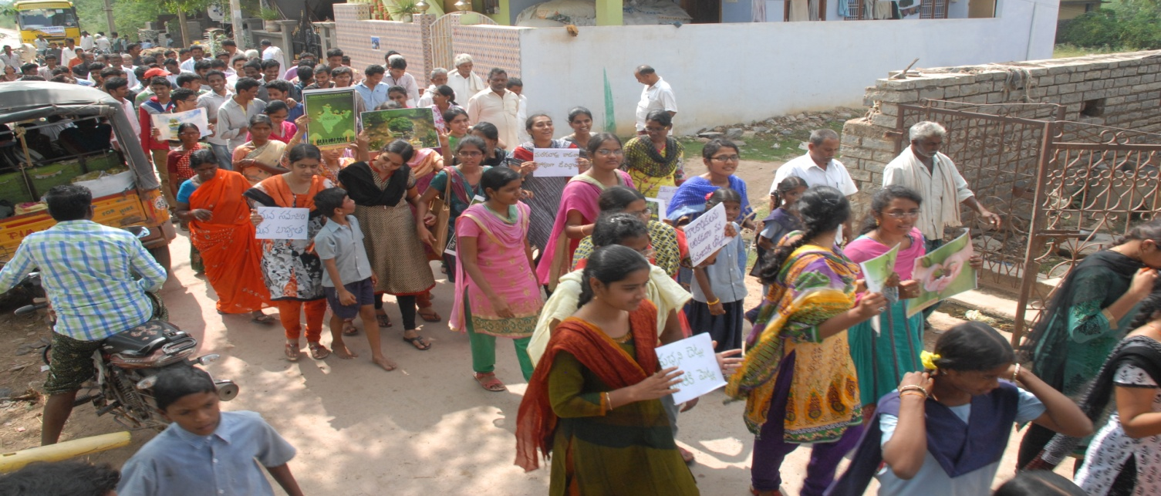
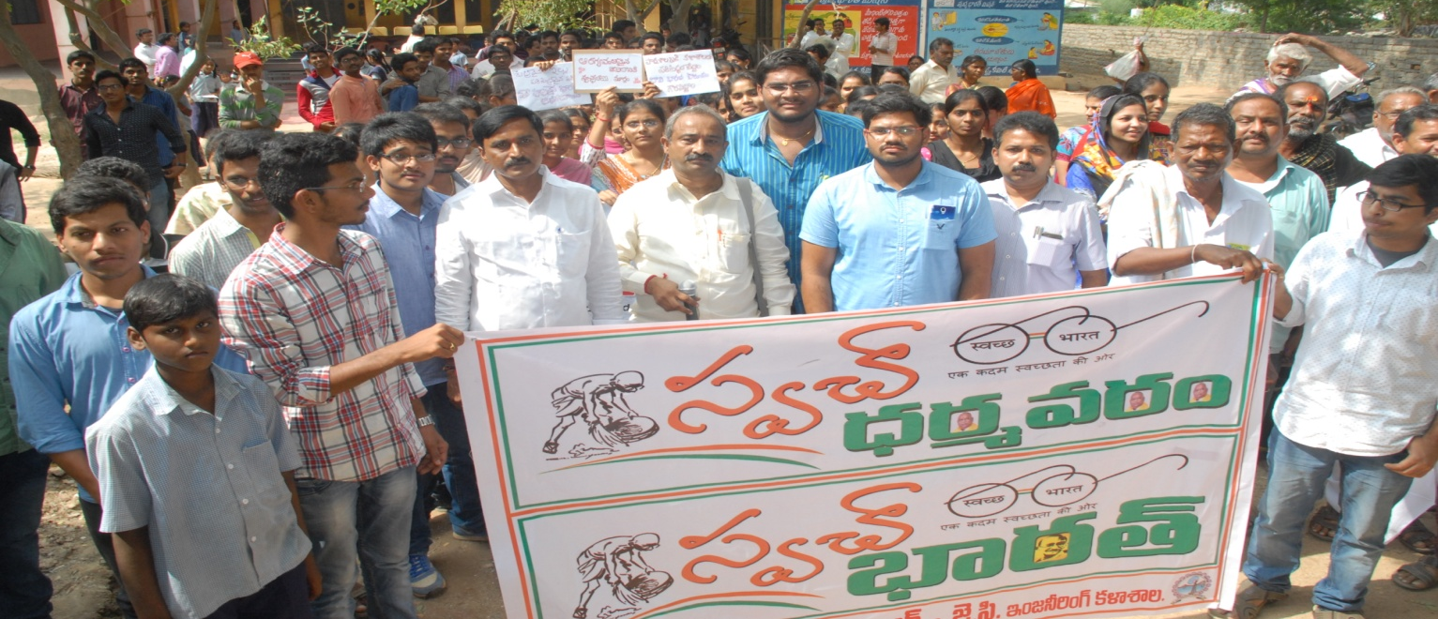
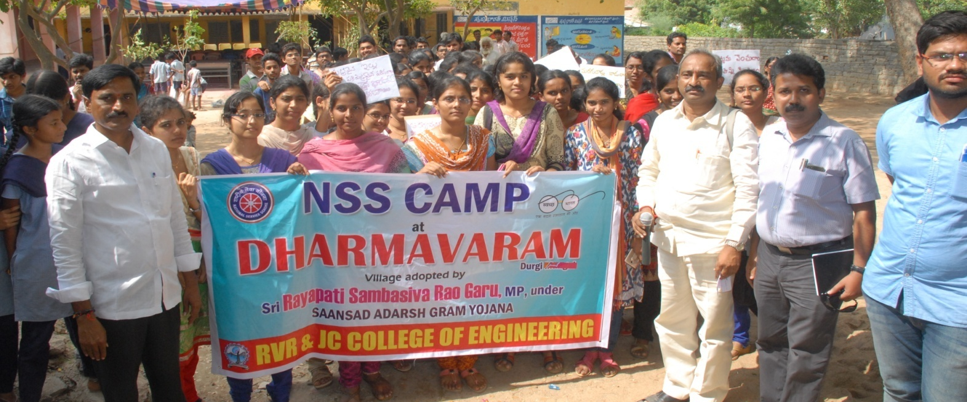
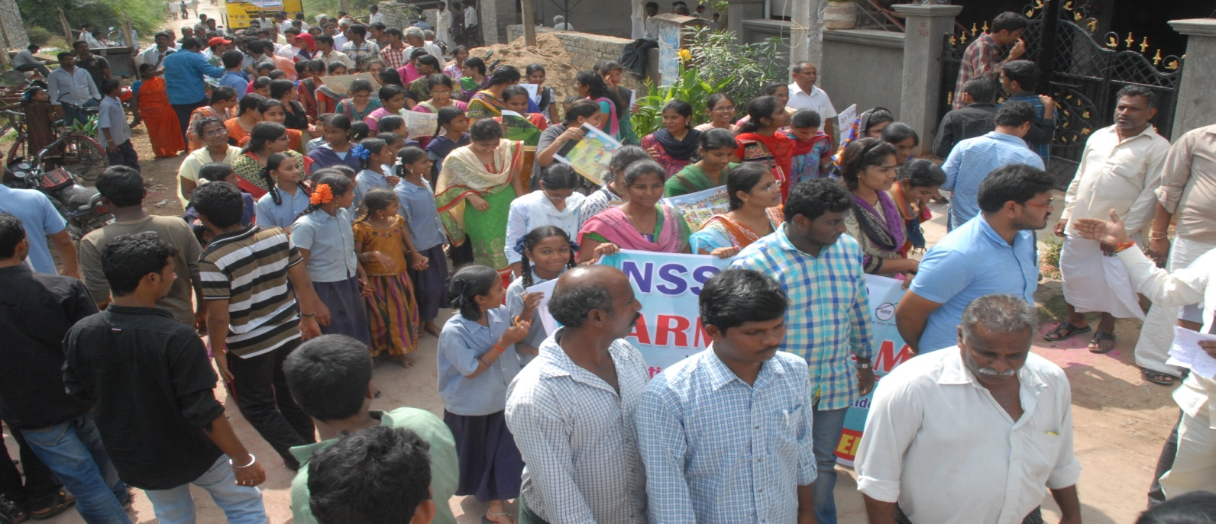

AWARENESS ON CASHLESS TRANSACTION
PROGRAMME
WITH CH.MADHU, VILLAGE PRESIDENT
SRI SAJI, PS TO MP
VILLAGE VICE PRESIDENT ALONG WITH NSS PO AND VOLUNTEERS

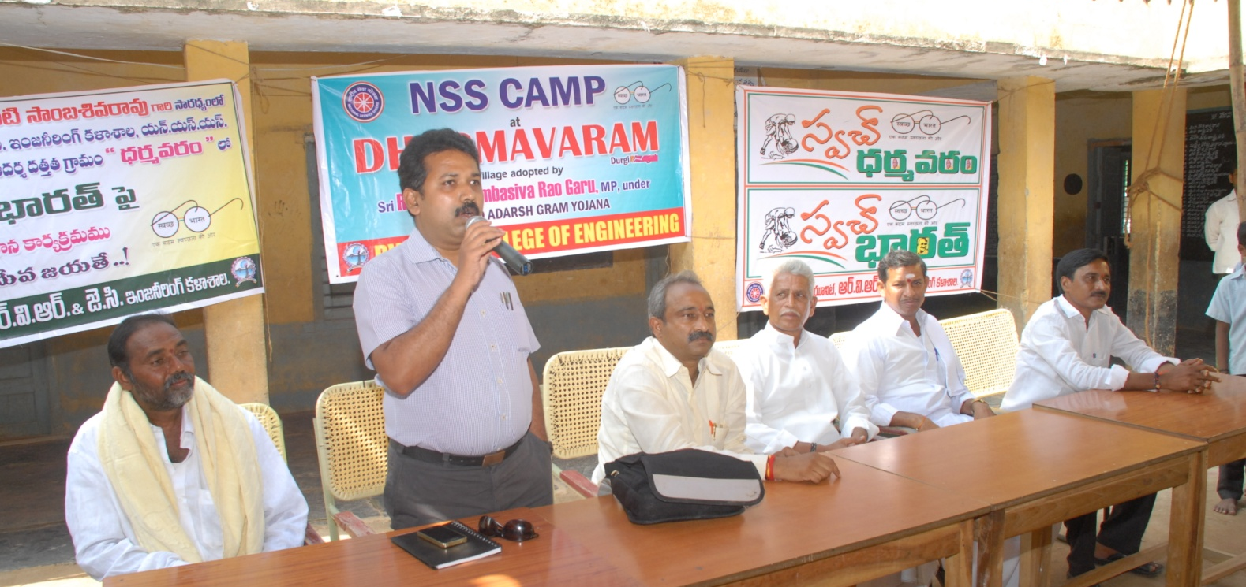
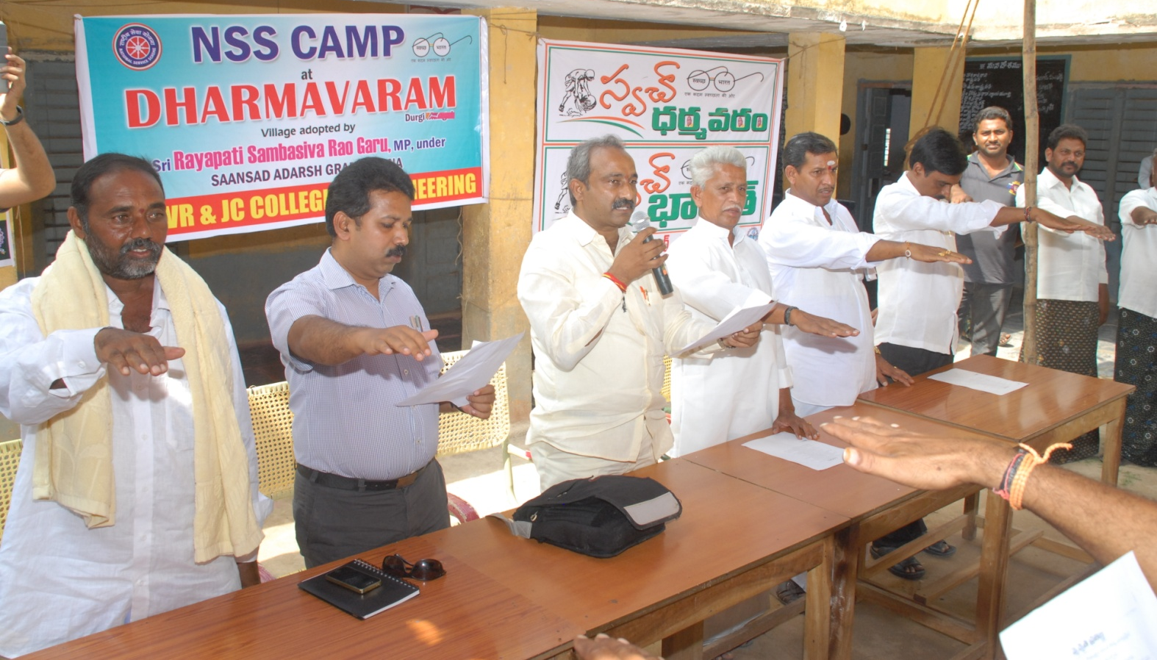
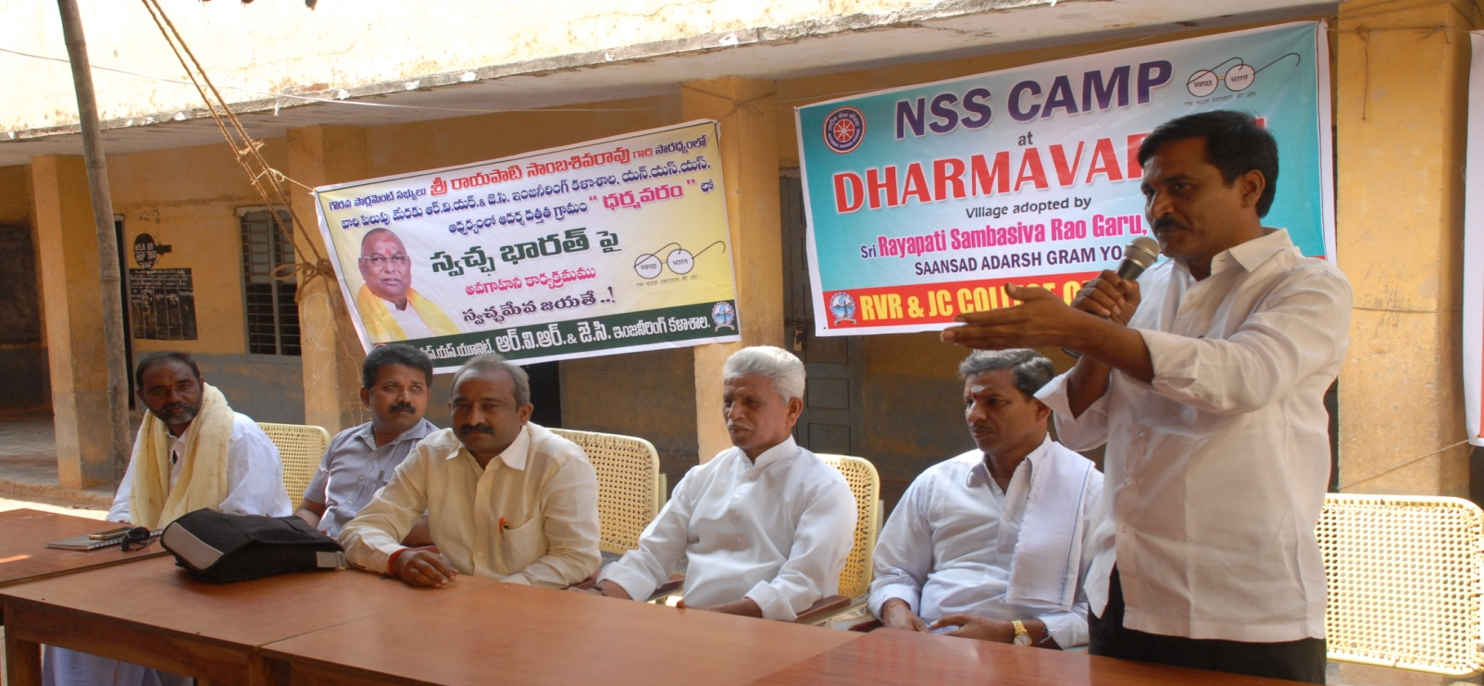
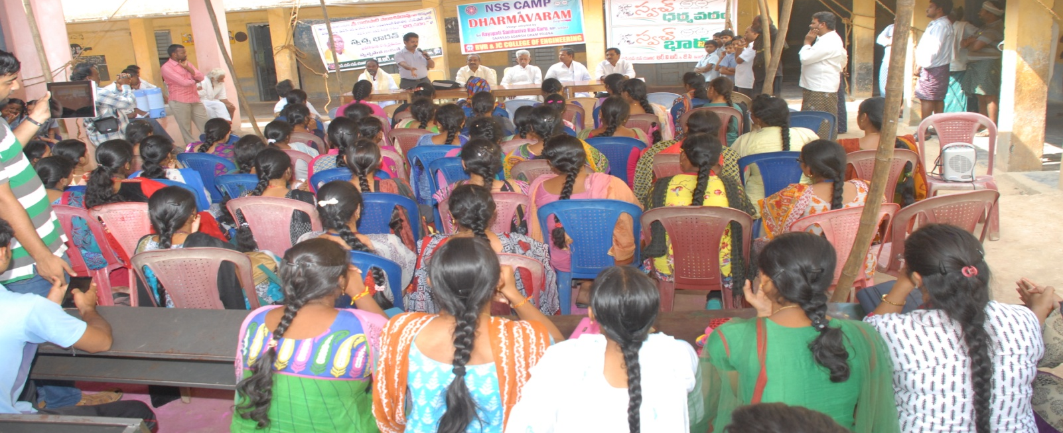
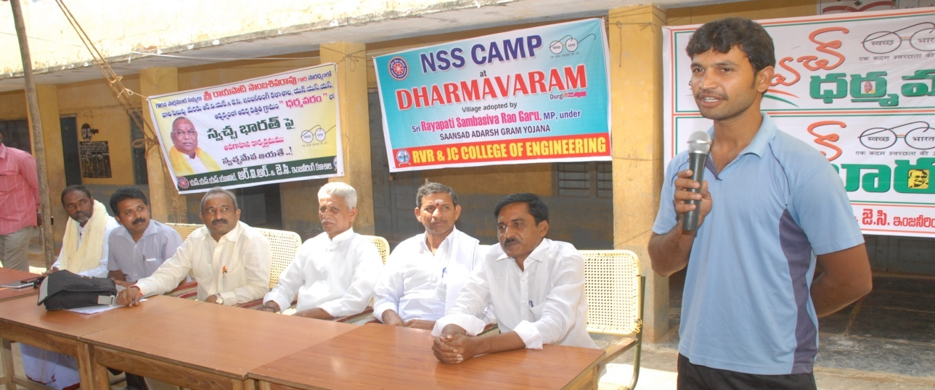
OUR NSS VOLUNTARY SERVICE FORCE @ DHARMAVARAM REMOTE VILLAGE
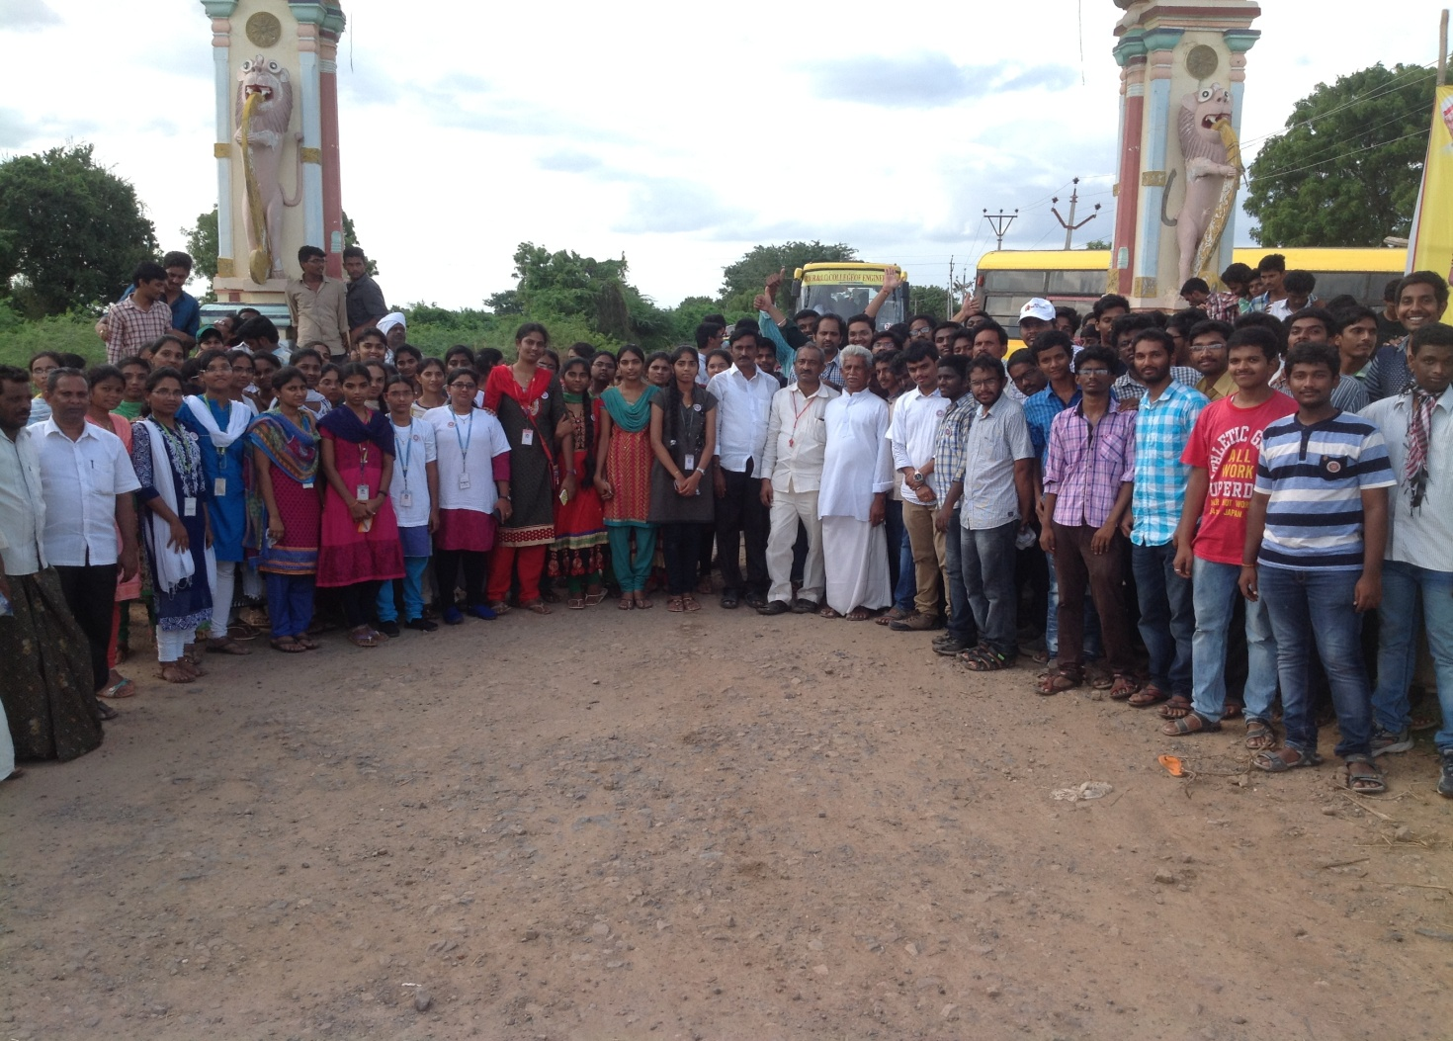
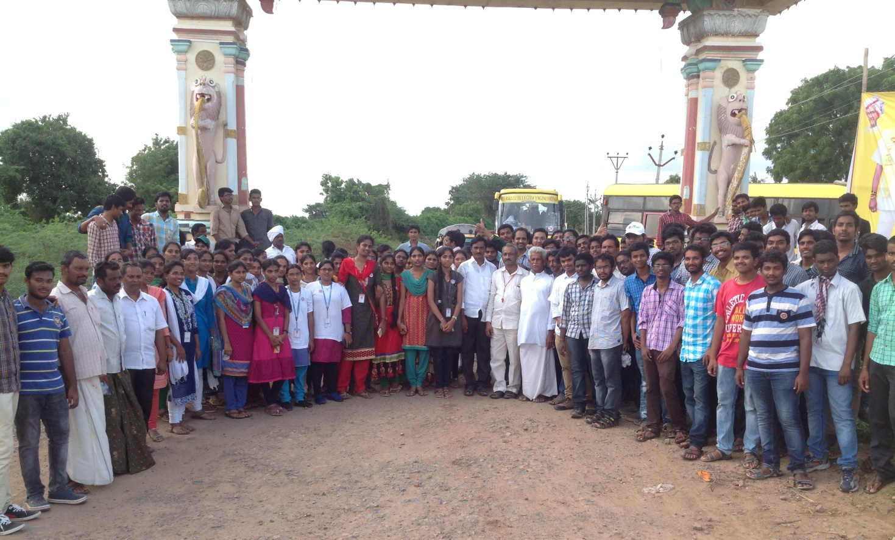
FELICITATION OF OUR NSS VOLUNTARY SERVICE FORCE BY
SRI RAYAPATI SAMBA SIVA RAO, MP(LOK SABHA,NARASARAOPET)
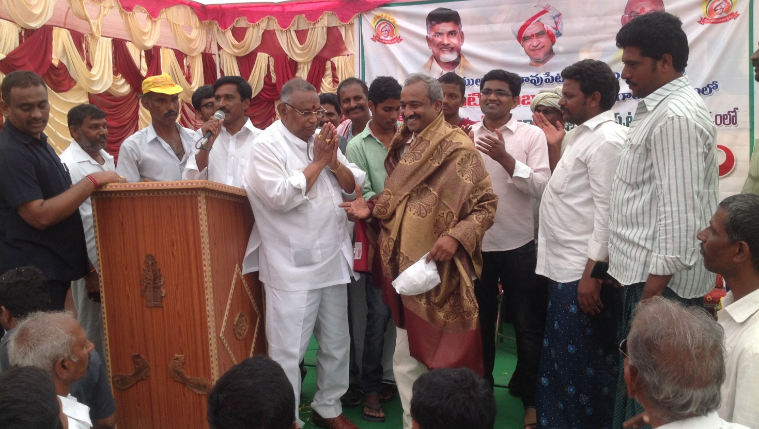
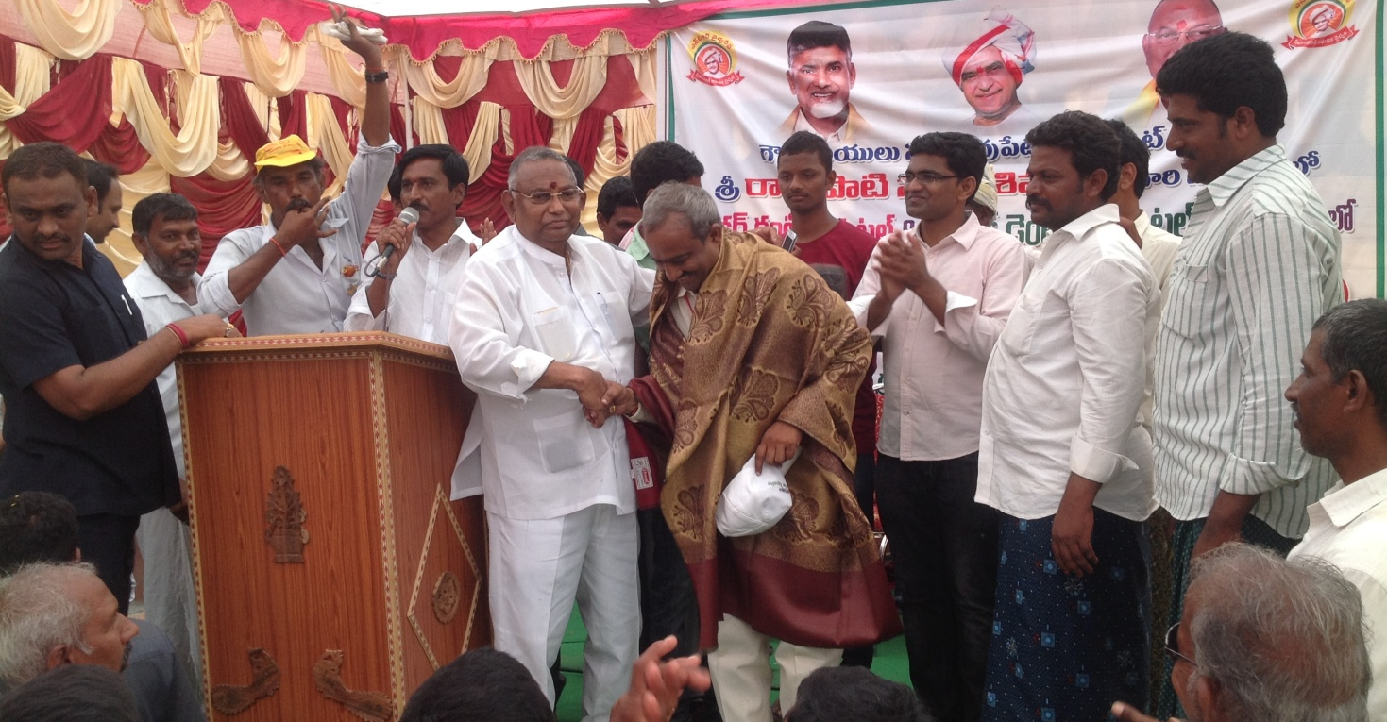
SPECIAL APPRECIATIONS TO OUR NSS HEADS BY MP SRI RAYAPATI SAMBASIVA RAO
- KALAKODIMI KRISHNA PRASAD, L14CS988
- ANGARA SREE SATYA BHEEMESH, Y13CE804

