N.S.S.ACTIVITIES during 2014-2015

- 140 of our NSS volunteers participated in SVEEP General Elections-2014 for Webcasting during polling at Narasaroapet division, coordinated by NSS PO, Sri M.Sudhakar
- NSS unit organized chilled mineral water camp for 4000 students & parents and serving free curd rice for 1000 students, parents during EAMCET-2014 held on 22-05-2014 at our college of cost about Rs.20,000/- with 25 NSS volunteers
- NSS activities manual 2013 – 14 of our unit was inaugurated by VC, Rector and NSS Co-Ordinator of ANU, on 12th June, 2014.
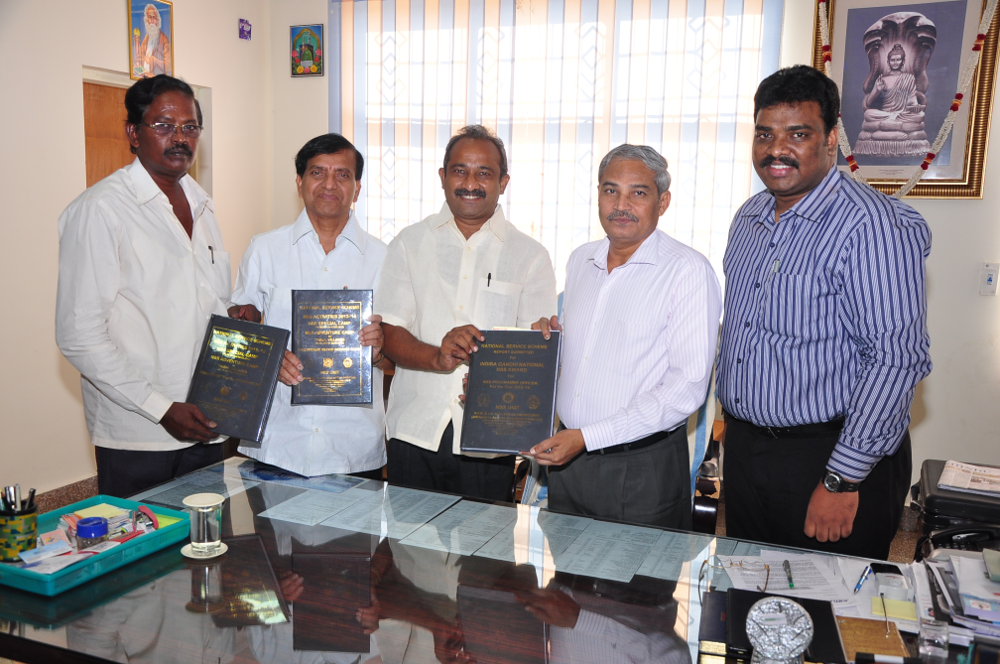
- NSS PO M.Sudhakar, received NTR Seva Purasakar – 2014 on the occasion of World Blood Donation Day on 14th June, 2014 at NTR Blood Bank, Memorial Trust Bhavan, Hyderabad through Smt. Paritala Sunitha, Minister of State, Civil Supplies, A.P. for donating his blood to the NTR Blood Bank and encouraging the youth about the Blood Donation.

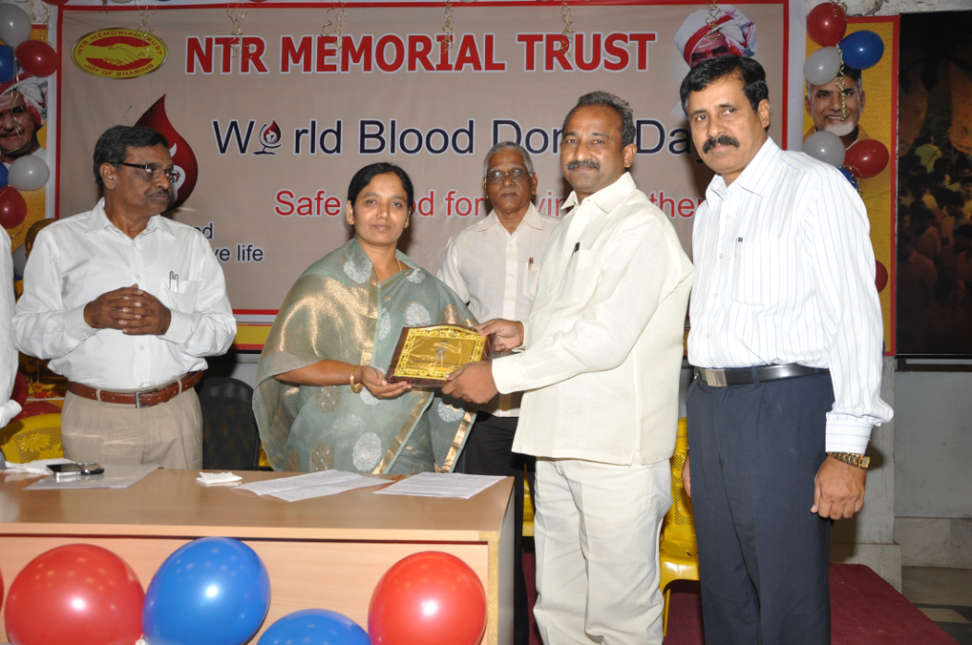
- Voluntary Blood Donors club of our college organized blood donation camp on 09-07-2014 and 50 of our NSS volunteers donated their blood at NTR Memorial Trust Blood Bank, Guntur and the camp was organized by NSS unit of our college. The Camp was inaugurated by Ex.MLC Sri Rayapati Srinivas Garu on this occasion NSS PO M.Sudhakar felicitated by our MLC through NTR Memorial Blood Bank for donating his blood highest no.of times (47 times)
